Skyhook Accelerated



# Abstract

This report investigates the potential for MR damping suspensions to elevate C3 vehicles above those of competitors. A Matlab simulation was conducted to compare the performance of a standard suspension with that of an MR Damper under a Skyhook or modified Skyhook control algorithm. Results show that MR suspensions due generally reduce car body vibrations in low velocity or low frequency scenarios, but may actually amplify such vibrations in high velocity or high frequency cases. Further work is needed to modify skyhook algorithm to account for such cases, perhaps via velocity thresholds for automatically shutting off the MR damper during unfavorable conditions, or by utilizing artificial neural networks or other machine learning algorithms for improved control.

Table of Contents

Abstract 1

Introduction 3

Analysis 4

Methods - Programming 4

Methods - Skyhook Algorithms 5

Results 6

Conclusions 7

References 7

Appendix 8

Supplemental Equations 8

Result Tables 8

Result Figures 14

MATLAB Code 32

# Introduction

The C3 Company believes that utilizing smart materials in the production of C3 vehicles will generate increased market interest in C3‘s lineup compared with our local, national, and international competitors. Our suspension system in particular has lagged behind our competitors in recent years as several of them have begun incorporating Magnetorheological (MR) fluid as an additional semi-active damping component in their high-end and luxury vehicle models. MR Fluids consist of suspended magnetic particles that rapidly align in response to a magnetic field, exerting a force that can be applied – in this use case – to resist motion by absorbing and dissipating energy (**Figure 1** [1]). However, the high cost of current semi-active MR damping systems available on the market (such as the GM Magnetic Selectable Ride Control system) has limited the incorporation of the system in low- and mid-range vehicles. Designing an MR suspension system in-house at C3 will reduce the long-term cost of the system and thus generate a larger return-on-investment as our full range of vehicles will be more attractive to consumers compared to competitors low- and mid-range vehicles with standard suspension systems.

Several MR damping and associated control algorithms are on the market, including proprietary suspension systems such as GM’s Magnetic Selectable Ride Control system (Magneride) and BMW’s Dynamic Damping Control (DDC) as well as control algorithms Groundhook and Skyhook, among others [1]–[3]. These systems are described as “Semi-Active”, given that they do not directly control the vertical position of the wheel; instead, they modulate the damping force to adjust the wheel’s response to the road with the goal of vibration isolation [1], [3]. By and large, these systems find an optimal balance between simplicity, low-power requirements, and efficacy. Skyhook Control Algorithm is particularly interesting due to its binary force output conditions. Such controls allow the system to be turned off when it’s not needed or when it would induce a resonate spike in vibration; it can then be turned back on with a response time in the range of milliseconds [1].

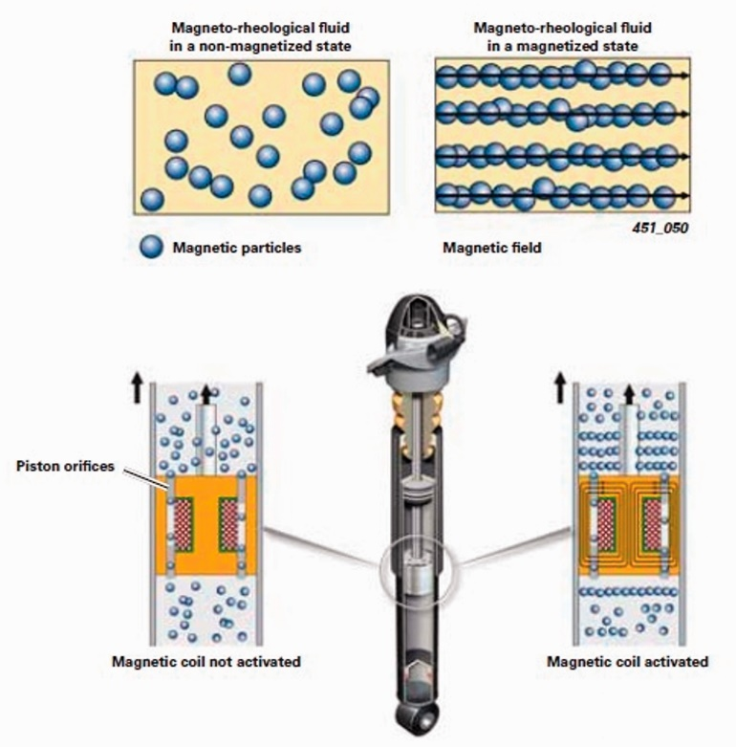

Figure 1. Representative magnetorheological suspension system. Reproduced from Soliman & Kaldas (2021) [1].

A. Soliman and M. Kaldas, “Semi-active suspension systems from research to mass-market – A review,” *Journal of Low Frequency Noise, Vibration and Active Control*, vol. 40, no. 2, pp. 1005–1023, Jun. 2021, doi: 10.1177/1461348419876392

A simulation of an MR damper was performed in MATLAB to assess the feasibility of an MR damping system for further development. Skyhook Control Algorithm, being a well-researched and high performing control system, was chosen as the baseline for further modification. Briefly, a single degree of freedom suspension was modeled whereby the input to the system was a sinusoidal wave function (the road surface) and the output being the vertical motion of the car bod, described by displacement, velocity, and acceleration. A single wheel & sprung mass system to model the vehicle was chosen for simplicity. A standard suspension was modeled as a parallel spring and damper system; an MR damper was added (in parallel) to simulate the novel system and trial various control algorithms.

# Analysis

## Methods - Programming

Full Matlab code for the simulation can be found in the Appendix. To begin, all pertinent variables were entered; importantly, the vertical displacement, velocity, and acceleration of the car body were initialized to zero for both the starting time point (x0, dx0, ddx0) and first iteration of the loop (x1, dx1, ddx1). This was a requirement for the integration method (described later). Additionally, two true/false statements were included to determine the direction for simulation. The user could select true/false to use an MR damper (false would result in a suspension with no MR), then whether to use the basic or modified Skyhook algorithm. A for loop was opened to complete the simulation of the suspension for each time point (i = 10,000 timepoints with dt = 0.0005 s). Within the for loop, the vertical position, velocity, and acceleration for the road input were calculated using the amplitude equation for a sinusoidal wave and taking the first & second derivatives (**Equations 1.1-1.3**).

### Equation 1.1: Amplitude of the Road Input

$y=y_{0}*\sin\left(ω_{e}*i_{t}*dt\right)$

Where y0 is the amplitude, it is the time point, dt is the time step, and ωe is the excitation frequency (Equation S1)

### Equation 1.2: Rate of Change of the Road Input

$dy=y_{0}*ω_{e}*\cos{(ω_{e}*i_{t}*dt)}$

### Equation 1.3: Acceleration of the Road Input

$d^{2}y=y_{0}*-1*ω_{e}^{2}*\sin{(ω_{e}*i_{t}*dt)}$

The simulation then enters another for loop (10 iterations) to calculate the vertical motion of the car body by Newmark-Beta numerical integration. Ten iterations were used such that the integral could converge on a final value. Initial values were calculated for displacement (**Equation 2.1**) and velocity (**Equation 2.2**), then an if statement determines whether to include an MR damper for calculating acceleration.

### Equation 2.1: Vertical Displacement of the Vehicle

$x_{1}= x_{0}+\left({dx}_{0}*dt\right)+\left(\left(\left(0.5-β\right)*d^{2}x_{0}\right)+\left(β*d^{2}x_{1}\right) \right)*d^{2}t$

Where *β* is an integration constant

### Equation 2.2: Vertical Velocity of the Vehicle

$dx_{1}={dx}_{0}+\left(\left(\left(1-Λ\right)*d^{2}x_{0}\right)+\left(Λ*d^{2}x_{1}\right) \right)*dt$

Where *Λ* is an integration constant

For a standard suspension, the spring (**Equation 3**) & damping forces (**Equation 4**) for the suspension were calculated; these were then used to calculate acceleration (**Equation 2.3A**). For an MR Suspension, a series of if statements determine whether to use the standard or modified Skyhook algorithm to determine Fyield for the MR Damper (described below). The force output for the spring (**Equation 3**), standard damping (**Equation 4**), and MR damping (**Equation 5**) components of the suspension are then calculated and used in the calculation of acceleration (**Equation 2.3B**). The displacement, velocity, and acceleration are then saved as new x1, dx1, and ddx1 values and used to calculate the next integration according to Newmark-Beta. After 10 iterations, the program saves the final output of the integration loop for displacement, velocity, acceleration, spring force, damping force, and MR damping force in an array and moves on to the next time point.

### Equation 2.3A: Vertical Acceleration of the Vehicle with Standard Suspension

$d^{2}x_{1}=\frac{-1}{M}*(F_{s}+F_{d})$

Where *M* is the mass of the vehicle and *Fs* & *Fd* are from **Equations 3 & 4**, respectively

### Equation 2.3B: Vertical Acceleration of the Vehicle with MR Damping

$d^{2}x_{1}=\frac{-1}{M}*(F_{s}+F_{d}+F_{a})$

Where *M* is the mass of the vehicle and *Fs*, *Fd,* & *Fa* are from **Equations 3, 4 & 5**, respectively

After calculating every timepoint the program then finds the maximum (absolute value) displacement, velocity, acceleration, and force values. Only the second half of the timepoints are searched to avoid selecting values that are a consequence of frequency noise from the initial stages of integration when the calculations have not converged. Finally, variables are output and graphs for the motion and force characteristics described previously are plotted vs. time.

### Equation 3: Force in the Suspension Spring

$F_{s}=K*(x_{1}-y)$

Where *K* is the spring constant

### Equation 4: Force in the Suspension Damper

$F_{d}=C*({dx}_{1}-dy)$

Where *C* is the damping constant of the standard damper

### Equation 5: Force in the MR Damper

$F_{a}={(F}_{yield}*sign({dx}_{1}-dy))+(C_{mr}*({dx}_{1}-dy))$

Where *Fyield* is the nominal force output of the MR damper and *Cmr* is the MR damping constant

## Methods - Skyhook Algorithms

Skyhook Control Algorithm uses a series of if statements to determine what force to output as Fyield in **Equation 5**. If the rate of change of the road is moving faster & in the same direction as the vertical velocity of the vehicle, the MR damper is turned off (Fyield = 0) as it would increase the velocity of the vehicle. Otherwise – if the rate of change of the road is in the opposite direction of the vertical velocity of the vehicle, or the vehicle is moving faster than the road – Fyield is set to max to slow the vertical velocity of the vehicle.

To modify the Skyhook algorithm, one additional condition was added. As in the original algorithm, if the rate of change of the road is moving faster & in the same direction as the vertical velocity of the vehicle, the MR damper is turned off (Fyield = 0). However, the algorithm now considers relative acceleration of the vehicle and road to determine when to turn the MR damper on in the other case. If the velocity of the car is larger than that of the road and the acceleration of the vehicle is larger than the acceleration of the road, the MR turns on to slow the relative acceleration. On the other hand, if the velocity of the car is larger than that of the road but the acceleration of the road is larger, then the MR damper turns off as the car body’s velocity is already slowing. This is held for both the positive and negative velocity cases. Theoretically, this would limit the damper from acting when it is not needed, thereby reducing overcorrection.

## Results

The simulation was run for 12 car velocity & road wavelength scenarios for each of the three suspension set ups. Car velocities to were chosen to be 7.333, 20.1317, 58.66, and 88 ft/sec to represent typical driving conditions (5 mph to 60 mph). Road wavelengths were chosen to be sinusoids of 10, 20, and 88 ft wavelengths. This provided a full range of scenarios where the car was faster than the road, where the road & car were of equal velocities, and where the road was faster than the car. Tables and Figures for each run can be found in the **Appendix, Tables 1-12 & Figures 2-37**.

For eight out of 12 simulation scenarios MR Damping reduced the vertical velocity of the car body relative to no MR damping control, with only a marginal (0.4%) increase in a ninth scenario. The four scenarios that did see an increase in car vertical velocity relative to control were all in high velocity scenarios (58.66 & 88 ft/s) with low frequency inputs (10 & 20 ft). These were all scenarios where the frequency ratio was > 2. No scenario with a frequency ratio less than two performed worse under the original skyhook control law. Given that the excitation frequency is a function of car velocity / wavelength, this makes sense. The semi-active control system works by dissipating energy at its natural frequency directed into the car body by the vertical acceleration caused by changing road height. If the excitation frequency is high, the MR Damper will not be able to produce sufficient force to combat the high energy input into it at the high frequencies. Thus, the damper will actually amplify the motion caused by high frequency waves surpassing the output frequency. One possible avenue for improving algorithm performance would thus be to turn the MR damper off at high velocity.

In many cases, the modified skyhook algorithm showed no change in peak velocity relative to the original algorithm. This is logical given that the Fyield produced by the MR damper is exactly equal in many scenarios. Of the four logic scenarios in the original algorithm, two are exactly replicated in the modified algorithm. The other two logic scenarios are further split where only half of the scenarios will result in an Fyield output different from the same scenario with the original control. In scenarios where there is a difference in peak velocity between the algorithms, the difference is quite small. It is worth that both cases where there was a significant difference in peak velocity performance (-17% and -10.7%) where both scenarios where the car took more than a second to travel a full wavelength (7.333 ft/s against 10 ft wavelength, and 58.66 ft/s against 88 ft wavelength).

Max vertical displacement and displacement closely follows the other metrics previously described. Acceleration was large (> 7 ft/s2) in the four scenarios where the MR damper made performance worse. Interestingly, max displacement actually had the opposite relationship, where displacement was less than 0.01 ft in low performing skyhook cases. This likely relates back to the frequency ratio; the direction of motion oscillating so rapidly likely prevented overall displacement from moving too far from zero.

# Conclusions

Overall, MR damping suspensions seem a worthwhile avenue for C3 to pursue. Additional work is needed to fully ascertain feasibility of an MR damping system in C3 vehicles. This simulation should first be expanded to a fully vehicle model (with four wheels) to determine how weight distribution would impact performance. The work in this report assumes a perfectly sinusoidal road, but no road is constructed perfectly or regularly. Simulations should be conducted to better reflect real world driving conditions, including potholes (step input) [2] or roads with “out-of-plane” tilts where the tires on the same axis are not level with each other. Tire elasticity should also be added to future models. Subsequently, a physical model of a real-world MR damper should be produced to validate these results and compare against competitors’ models before moving towards production.

Several avenues may be pursued to further improve the Skyhook algorithm. One possibility would be to add an additional control to limit its use case in high velocity scenarios. Given that the algorithm performed best when the horizontal velocity of the car was low, turning off the MR damper at high speeds (50 ft/s, for instance) or when sensors detect high speeds relative to low road wavelengths may limit low-performance scenarios. Additionally, research is being conducted into whether Deep Learning algorithms may be a suitable control or analysis tool for MR damping systems[1]. An artificial neural network may be able to identify patterns in algorithm performance that would not be detectable to a human researcher or engineer. Engineers would then be able to take that data and modify the Skyhook algorithm (or other control) accordingly. Alternatively, it could be incorporated directly into the MR suspension to produce real-time adjustments.

# References

[1] A. Soliman and M. Kaldas, “Semi-active suspension systems from research to mass-market – A review,” *Journal of Low Frequency Noise, Vibration and Active Control*, vol. 40, no. 2, pp. 1005–1023, Jun. 2021, doi: 10.1177/1461348419876392.

[2] C. S. Díaz-Choque, L. C. Félix-Herrán, and R. A. Ramírez-Mendoza, “Optimal Skyhook and Groundhook Control for Semiactive Suspension: A Comprehensive Methodology,” *Shock and Vibration*, vol. 2021, pp. 1–21, Dec. 2021, doi: 10.1155/2021/8084343.

[3] A. Trevitt, “Semi-Active Suspension,” *Cycle World Lifestyle*, 2014.

# Appendix

## Supplemental Equations

### Supplementary Equation S1: Excitation Frequency

$ω_{e}=\frac{2π*s}{λ},$ where *s* is the horizontal velocity of the car and *λ* is the wavelength of the road.

### Supplementary Equation S2: Natural Frequency

$ω_{n}=\sqrt{\frac{K}{M}}$, where *K* is the spring constant of the suspension system & *M* is the mass of the car body.

### Supplementary Equation S3: Frequency Ratio

$frequency ratio=\frac{ω_{e}}{ω_{n}}$

### Supplementary Equation S4: Velocity Ratio

$velocity ratio=\frac{{dx}_{max}}{s}$, where dxmax is the maximum vertical velocity of the car and s is the horizontal velocity

### Supplementary Equation S5: Percent Improvement

$\%Improvement=\frac{{dx}_{control}-{dx}_{new}}{{dx}_{control}}*100\%$

## Result Tables

### Table 1: Comparison of the Three Suspension Systems When Car Speed = 7.333 ft/sec & Road Wavelength = 10 ft

|  |  |  |  |
| --- | --- | --- | --- |
|  | No MR Damping | Skyhook Control | Modified Skyhook Control |
| Road Wavelength (ft) | 10 | | |
| Car Speed (ft/sec) | 7.333 | | |
| Excitation Frequency (Hz) | 4.6075 | 4.6075 | 4.6075 |
| Natural Frequency (Hz) | 6.3246 | 6.3246 | 6.3246 |
| Frequency Ratio (we/wn) | 0.7285 | 0.7285 | 0.7285 |
| Car Max Displacement (ft) | 0.2041 | 0.0408 | 0.0937 |
| Car Max Velocity (ft/sec) | 1.0184 | 0.3896 | 0.456 |
| Velocity Ratio (ratio) | 0.1389 | 0.0531 | 0.0622 |
| Car Max Acceleration (ft/sec^2) | -4.397 | -2.5065 | -2.4159 |
| Max Spring Force (lb) | -442.6842 | -237.7295 | 237.7655 |
| Max Damper Force (lb) | 57.5553 | -41.8098 | 27.7338 |
| Max MR Damper Force (lb) | 0.0000 | 483.3392 | 2.7734 |
| Velocity Improvement  (%, Relative to No MR Damping) | 0.00% | 61.74% | 55.22% |
| Velocity Improvement  ( %, Relative to Skyhook Control) | -161.40% | 0.00% | -17.04% |

### Table 2: Comparison of the Three Suspension Systems When Car Speed = 20.1317 ft/sec & Road Wavelength = 10 ft

|  |  |  |  |
| --- | --- | --- | --- |
|  | No MR Damping | Skyhook Control | Modified Skyhook Control |
| Road Wavelength (ft) | 10 | | |
| Car Speed (ft/sec) | 20.1317 | | |
| Excitation Frequency (Hz) | 12.6491 | 12.6491 | 12.6491 |
| Natural Frequency (Hz) | 6.3246 | 6.3246 | 6.3246 |
| Frequency Ratio (we/wn) | 2 | 2 | 2 |
| Car Max Displacement (ft) | -0.0476 | 0.0284 | -0.0277 |
| Car Max Velocity (ft/sec) | -0.5149 | -0.415 | 0.4092 |
| Velocity Ratio (ratio) | -0.0256 | -0.0206 | 0.0203 |
| Car Max Acceleration (ft/sec^2) | 6.14 | 6.3064 | -6.5655 |
| Max Spring Force (lb) | -587.1831 | 406.3923 | 407.7331 |
| Max Damper Force (lb) | -175.0413 | 123.7484 | 124.6713 |
| Max MR Damper Force (lb) | 0.0000 | -495.3617 | 495.4671 |
| Velocity Improvement  (%, Relative to No MR Damping) | 0.00% | 19.40% | 20.53% |
| Velocity Improvement  ( %, Relative to Skyhook Control) | -24.07% | 0.00% | 1.40% |

### Table 3: Comparison of the Three Suspension Systems When Car Speed = 58.66 ft/sec & Road Wavelength = 10 ft

|  |  |  |  |
| --- | --- | --- | --- |
|  | No MR Damping | Skyhook Control | Modified Skyhook Control |
| Road Wavelength (ft) | 10 | | |
| Car Speed (ft/sec) | 58.66 | | |
| Excitation Frequency (Hz) | 36.8572 | 36.8572 | 36.8572 |
| Natural Frequency (Hz) | 6.3246 | 6.3246 | 6.3246 |
| Frequency Ratio (we/wn) | 5.8276 | 5.8276 | 5.8276 |
| Car Max Displacement (ft) | -0.0085 | 0.0057 | 0.0057 |
| Car Max Velocity (ft/sec) | -0.1791 | -0.2172 | -0.2156 |
| Velocity Ratio (ratio) | -0.0031 | -0.0037 | -0.0037 |
| Car Max Acceleration (ft/sec^2) | 5.7673 | -9.0595 | 8.9773 |
| Max Spring Force (lb) | -428.5365 | 404.1771 | 404.5784 |
| Max Damper Force (lb) | 382.0591 | -369.0724 | -368.9975 |
| Max MR Damper Force (lb) | 0.0000 | -519.9072 | -519.8998 |
| Velocity Improvement  (%, Relative to No MR Damping) | 0.00% | -21.27% | -20.38% |
| Velocity Improvement  ( %, Relative to Skyhook Control) | 17.54% | 0.00% | 0.74% |

### Table 4: Comparison of the Three Suspension Systems When Car Speed = 88 ft/sec & Road Wavelength = 10 ft

|  |  |  |  |
| --- | --- | --- | --- |
|  | No MR Damping | Skyhook Control | Modified Skyhook Control |
| Road Wavelength (ft) | 10 | | |
| Car Speed (ft/sec) | 88 | | |
| Excitation Frequency (Hz) | 55.292 | 55.292 | 55.292 |
| Natural Frequency (Hz) | 6.3246 | 6.3246 | 6.3246 |
| Frequency Ratio (we/wn) | 8.7424 | 8.7424 | 8.7424 |
| Car Max Displacement (ft) | -0.0051 | 0.0032 | -0.0034 |
| Car Max Velocity (ft/sec) | 0.1406 | -0.1812 | 0.1828 |
| Velocity Ratio (ratio) | 0.0016 | -0.0021 | 0.0021 |
| Car Max Acceleration (ft/sec^2) | 7.0261 | 11.035 | -10.9645 |
| Max Spring Force (lb) | -416.3465 | 401.7369 | -402.9572 |
| Max Damper Force (lb) | -562.0388 | -553.3311 | 553.4706 |
| Max MR Damper Force (lb) | 0.0000 | -538.3331 | 538.3471 |
| Velocity Improvement  (%, Relative to No MR Damping) | 0.00% | -28.88% | -30.01% |
| Velocity Improvement  ( %, Relative to Skyhook Control) | 22.41% | 0.00% | -0.88% |

### Table 5: Comparison of the Three Suspension Systems When Car Speed = 7.333 ft/sec & Road Wavelength = 20 ft

|  |  |  |  |
| --- | --- | --- | --- |
|  | No MR Damping | Skyhook Control | Modified Skyhook Control |
| Road Wavelength (ft) | 20 | | |
| Car Speed (ft/sec) | 7.333 | | |
| Excitation Frequency (Hz) | 2.3037 | 2.3037 | 2.3037 |
| Natural Frequency (Hz) | 6.3246 | 6.3246 | 6.3246 |
| Frequency Ratio (we/wn) | 0.3643 | 0.3643 | 0.3643 |
| Car Max Displacement (ft) | 0.1133 | -0.0707 | 0.0707 |
| Car Max Velocity (ft/sec) | 0.3105 | 0.2303 | 0.2303 |
| Velocity Ratio (ratio) | 0.0423 | 0.0314 | 0.0314 |
| Car Max Acceleration (ft/sec^2) | -0.7718 | 6.0059 | -6.0029 |
| Max Spring Force (lb) | 76.7859 | -117.4604 | 117.1624 |
| Max Damper Force (lb) | 10.4952 | 16.2787 | 16.2840 |
| Max MR Damper Force (lb) | 0.0000 | 483.0237 | 483.0116 |
| Velocity Improvement  (%, Relative to No MR Damping) | 0.00% | 25.83% | 25.83% |
| Velocity Improvement  ( %, Relative to Skyhook Control) | -34.82% | 0.00% | 0.00% |

### Table 6: Comparison of the Three Suspension Systems When Car Speed = 20.1317 ft/sec & Road Wavelength = 20 ft

|  |  |  |  |
| --- | --- | --- | --- |
|  | No MR Damping | Skyhook Control | Modified Skyhook Control |
| Road Wavelength (ft) | 20 | | |
| Car Speed (ft/sec) | 20.1317 | | |
| Excitation Frequency (Hz) | 6.3246 | 6.3246 | 6.3246 |
| Natural Frequency (Hz) | 6.3246 | 6.3246 | 6.3246 |
| Frequency Ratio (we/wn) | 1 | 1 | 1 |
| Car Max Displacement (ft) | -0.5876 | 0.043 | 0.043 |
| Car Max Velocity (ft/sec) | -3.6675 | 0.4546 | 0.4546 |
| Velocity Ratio (ratio) | -0.1822 | 0.0226 | 0.0226 |
| Car Max Acceleration (ft/sec^2) | 23.4693 | 3.228 | 3.228 |
| Max Spring Force (lb) | -2318.1 | -303.5303 | -303.5303 |
| Max Damper Force (lb) | -362.2141 | -57.6096 | -57.6096 |
| Max MR Damper Force (lb) | 0.0000 | -485.7131 | -485.7131 |
| Velocity Improvement  (%, Relative to No MR Damping) | 0.00% | 87.60% | 87.60% |
| Velocity Improvement  ( %, Relative to Skyhook Control) | -706.75% | 0.00% | 0.00% |

### Table 7: Comparison of the Three Suspension Systems When Car Speed = 58.66 ft/sec & Road Wavelength = 20 ft

|  |  |  |  |
| --- | --- | --- | --- |
|  | No MR Damping | Skyhook Control | Modified Skyhook Control |
| Road Wavelength (ft) | 20 | | |
| Car Speed (ft/sec) | 58.66 | | |
| Excitation Frequency (Hz) | 18.4286 | 18.4286 | 18.4286 |
| Natural Frequency (Hz) | 6.3246 | 6.3246 | 6.3246 |
| Frequency Ratio (we/wn) | 2.9138 | 2.9138 | 2.9138 |
| Car Max Displacement (ft) | -0.0234 | -0.0154 | -0.0152 |
| Car Max Velocity (ft/sec) | 0.3222 | -0.3235 | -0.3199 |
| Velocity Ratio (ratio) | 0.0055 | -0.0055 | -0.0055 |
| Car Max Acceleration (ft/sec^2) | 5.2966 | 7.0366 | 7.1818 |
| Max Spring Force (lb) | -483.8191 | -407.2956 | -407.5529 |
| Max Damper Force (lb) | 213.9460 | 184.1532 | -184.3117 |
| Max MR Damper Force (lb) | 0.0000 | 501.4153 | -501.4312 |
| Velocity Improvement  (%, Relative to No MR Damping) | 0.00% | -0.40% | 0.71% |
| Velocity Improvement  ( %, Relative to Skyhook Control) | 0.40% | 0.00% | 1.11% |

### Table 8: Comparison of the Three Suspension Systems When Car Speed = 88 ft/sec & Road Wavelength = 20 ft

|  |  |  |  |
| --- | --- | --- | --- |
|  | No MR Damping | Skyhook Control | Modified Skyhook Control |
| Road Wavelength (ft) | 20 | | |
| Car Speed (ft/sec) | 88 | | |
| Excitation Frequency (Hz) | 27.646 | 27.646 | 27.646 |
| Natural Frequency (Hz) | 6.3246 | 6.3246 | 6.3246 |
| Frequency Ratio (we/wn) | 4.3712 | 4.3712 | 4.3712 |
| Car Max Displacement (ft) | -0.0125 | -0.0083 | 0.0083 |
| Car Max Velocity (ft/sec) | 0.213 | -0.2532 | 0.2507 |
| Velocity Ratio (ratio) | 0.0024 | -0.0029 | 0.0028 |
| Car Max Acceleration (ft/sec^2) | 5.345 | 8.0706 | -8.0246 |
| Max Spring Force (lb) | -443.5444 | -404.7392 | 405.6967 |
| Max Damper Force (lb) | -295.4723 | -276.9520 | -276.9574 |
| Max MR Damper Force (lb) | 0.0000 | -510.6952 | -510.6957 |
| Velocity Improvement  (%, Relative to No MR Damping) | 0.00% | -18.87% | -17.70% |
| Velocity Improvement  ( %, Relative to Skyhook Control) | 15.88% | 0.00% | 0.99% |

### Table 9: Comparison of the Three Suspension Systems When Car Speed = 7.333 ft/sec & Road Wavelength = 88 ft

|  |  |  |  |
| --- | --- | --- | --- |
|  | No MR Damping | Skyhook Control | Modified Skyhook Control |
| Road Wavelength (ft) | 88 | | |
| Car Speed (ft/sec) | 7.333 | | |
| Excitation Frequency (Hz) | 0.5236 | 0.5236 | 0.5236 |
| Natural Frequency (Hz) | 6.3246 | 6.3246 | 6.3246 |
| Frequency Ratio (we/wn) | 0.0828 | 0.0828 | 0.0828 |
| Car Max Displacement (ft) | 0.1021 | 0.0911 | 0.0911 |
| Car Max Velocity (ft/sec) | -0.0499 | -0.0453 | -0.0453 |
| Velocity Ratio (ratio) | -0.0068 | -0.0062 | -0.0062 |
| Car Max Acceleration (ft/sec^2) | -0.1136 | 5.1876 | 5.1877 |
| Max Spring Force (lb) | 11.2507 | -35.6471 | -35.6752 |
| Max Damper Force (lb) | 1.5120 | 2.1311 | 2.1591 |
| Max MR Damper Force (lb) | 0.0000 | 483.0238 | -483.0120 |
| Velocity Improvement  (%, Relative to No MR Damping) | 0.00% | 9.22% | 9.22% |
| Velocity Improvement  ( %, Relative to Skyhook Control) | -10.15% | 0.00% | 0.00% |

### Table 10: Comparison of the Three Suspension Systems When Car Speed = 20.1317 ft/sec & Road Wavelength = 88 ft

|  |  |  |  |
| --- | --- | --- | --- |
|  | No MR Damping | Skyhook Control | Modified Skyhook Control |
| Road Wavelength (ft) | 88 | | |
| Car Speed (ft/sec) | 20.1317 | | |
| Excitation Frequency (Hz) | 1.4374 | 1.4374 | 1.4374 |
| Natural Frequency (Hz) | 6.3246 | 6.3246 | 6.3246 |
| Frequency Ratio (we/wn) | 0.2273 | 0.2273 | 0.2273 |
| Car Max Displacement (ft) | -0.1101 | -0.0839 | -0.0839 |
| Car Max Velocity (ft/sec) | 0.167 | 0.1437 | 0.1437 |
| Velocity Ratio (ratio) | 0.0083 | 0.0071 | 0.0071 |
| Car Max Acceleration (ft/sec^2) | 0.4098 | -5.4752 | -5.4765 |
| Max Spring Force (lb) | -40.7236 | 64.3961 | 64.5303 |
| Max Damper Force (lb) | -3.8080 | -7.7941 | -7.7995 |
| Max MR Damper Force (lb) | 0.0000 | -483.0240 | 483.0120 |
| Velocity Improvement  (%, Relative to No MR Damping) | 0.00% | 13.95% | 13.95% |
| Velocity Improvement  ( %, Relative to Skyhook Control) | -16.21% | 0.00% | 0.00% |

### Table 11: Comparison of the Three Suspension Systems When Car Speed = 58.66 ft/sec & Road Wavelength = 88 ft

|  |  |  |  |
| --- | --- | --- | --- |
|  | No MR Damping | Skyhook Control | Modified Skyhook Control |
| Road Wavelength (ft) | 88 | | |
| Car Speed (ft/sec) | 58.66 | | |
| Excitation Frequency (Hz) | 4.1883 | 4.1883 | 4.1883 |
| Natural Frequency (Hz) | 6.3246 | 6.3246 | 6.3246 |
| Frequency Ratio (we/wn) | 0.6622 | 0.6622 | 0.6622 |
| Car Max Displacement (ft) | -0.1877 | -0.045 | 0.0839 |
| Car Max Velocity (ft/sec) | 0.8134 | 0.374 | -0.414 |
| Velocity Ratio (ratio) | 0.0139 | 0.0064 | -0.0071 |
| Car Max Acceleration (ft/sec^2) | 3.6094 | 2.6371 | 2.1988 |
| Max Spring Force (lb) | -358.5843 | -220.8234 | -216.4245 |
| Max Damper Force (lb) | 39.5441 | -37.1975 | -27.3303 |
| Max MR Damper Force (lb) | 0.0000 | 483.0636 | -2.7330 |
| Velocity Improvement  (%, Relative to No MR Damping) | 0.00% | 54.02% | 49.10% |
| Velocity Improvement  ( %, Relative to Skyhook Control) | -117.49% | 0.00% | -10.70% |

### Table 12: Comparison of the Three Suspension Systems When Car Speed = 88 ft/sec & Road Wavelength = 88 ft

|  |  |  |  |
| --- | --- | --- | --- |
|  | No MR Damping | Skyhook Control | Modified Skyhook Control |
| Road Wavelength (ft) | 88 | | |
| Car Speed (ft/sec) | 88 | | |
| Excitation Frequency (Hz) | 6.2832 | 6.2832 | 6.2832 |
| Natural Frequency (Hz) | 6.3246 | 6.3246 | 6.3246 |
| Frequency Ratio (we/wn) | 0.9935 | 0.9935 | 0.9935 |
| Car Max Displacement (ft) | -0.5894 | 0.0427 | 0.0427 |
| Car Max Velocity (ft/sec) | -3.6588 | 0.4528 | 0.4528 |
| Velocity Ratio (ratio) | -0.0416 | 0.0051 | 0.0051 |
| Car Max Acceleration (ft/sec^2) | 23.2822 | -3.1813 | -3.1813 |
| Max Spring Force (lb) | -2300 | 302.1238 | 302.1238 |
| Max Damper Force (lb) | -357.4706 | -57.2780 | -57.2780 |
| Max MR Damper Force (lb) | 0.0000 | -485.6067 | -485.6067 |
| Velocity Improvement  (%, Relative to No MR Damping) | 0.00% | 87.62% | 87.62% |
| Velocity Improvement  ( %, Relative to Skyhook Control) | -708.04% | 0.00% | 0.00% |

## Result Figures

### Figure 2: No MR Damping Suspension When Car Speed = 7.333 ft/sec & Road Wavelength = 10 ft

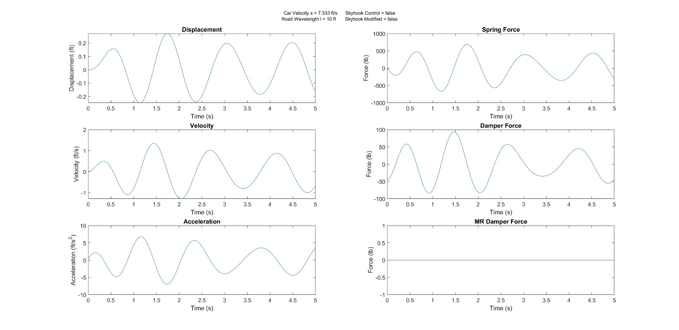

### Figure 3: MR Damping Suspension with Skyhook Control When Car Speed = 7.333 ft/sec & Road Wavelength = 10 ft

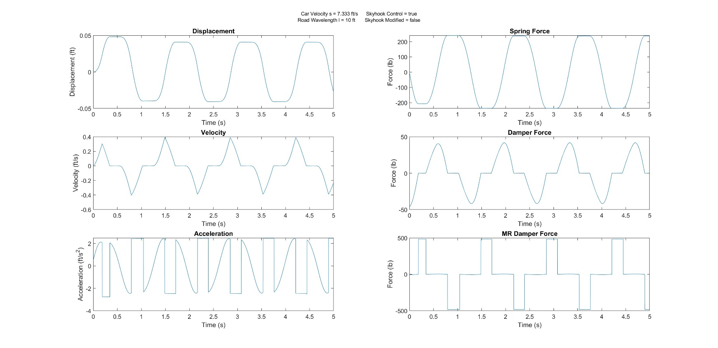

### Figure 4: MR Damping Suspension with Modified Skyhook Control When Car Speed = 7.333 ft/sec & Road Wavelength = 10 ft

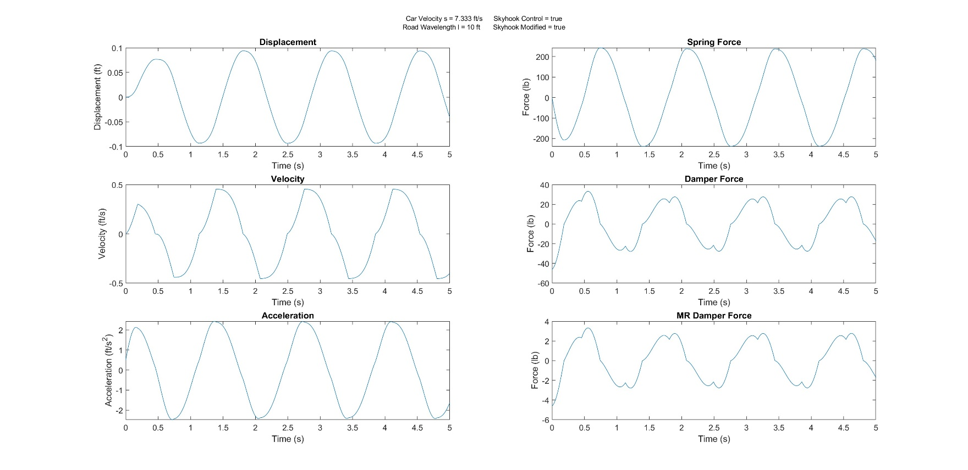

### Figure 5: No MR Damping Suspension When Car Speed = 20.1317 ft/sec & Road Wavelength = 10 ft

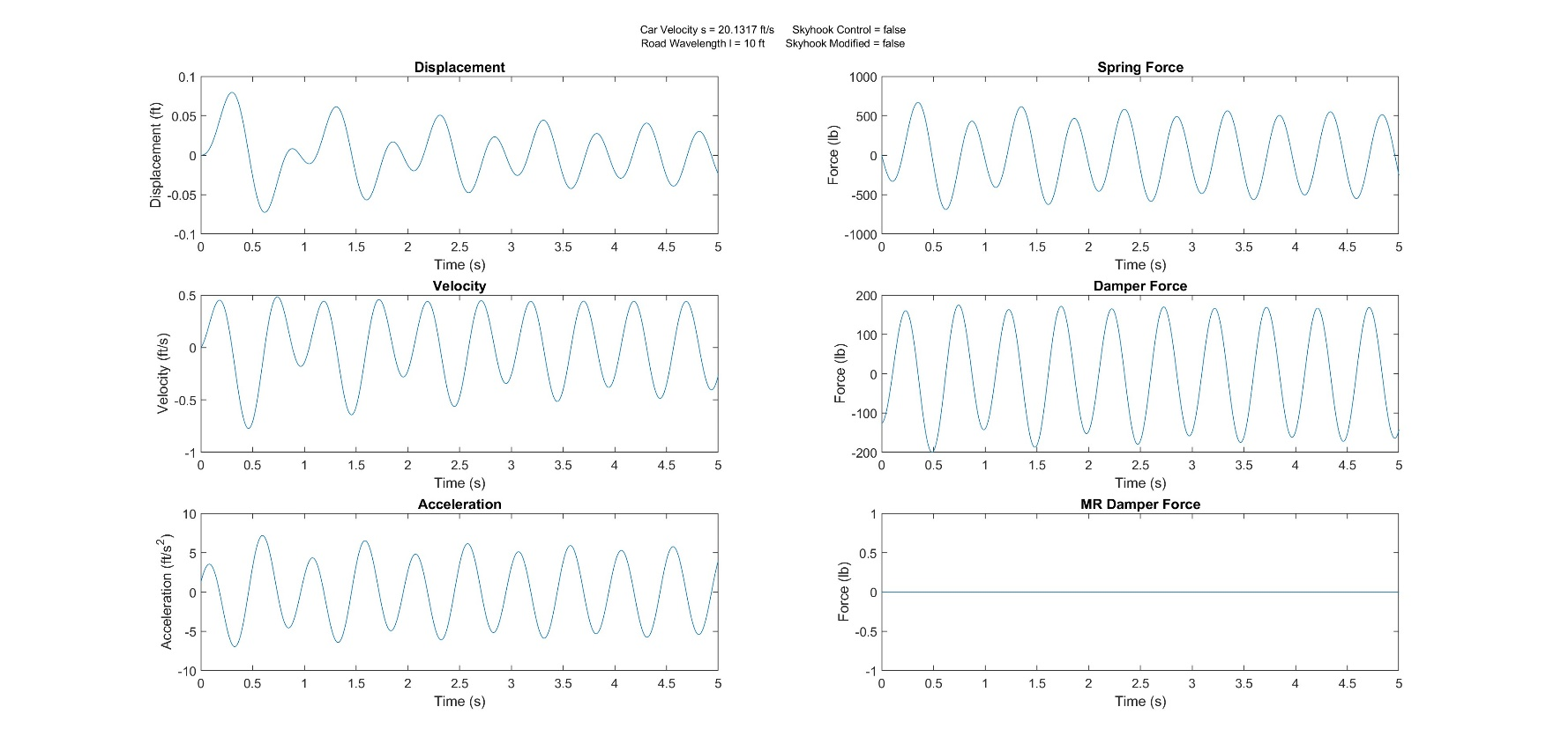

### Figure 6: MR Damping Suspension with Skyhook Control When Car Speed = 20.1317 ft/sec & Road Wavelength = 10 ft

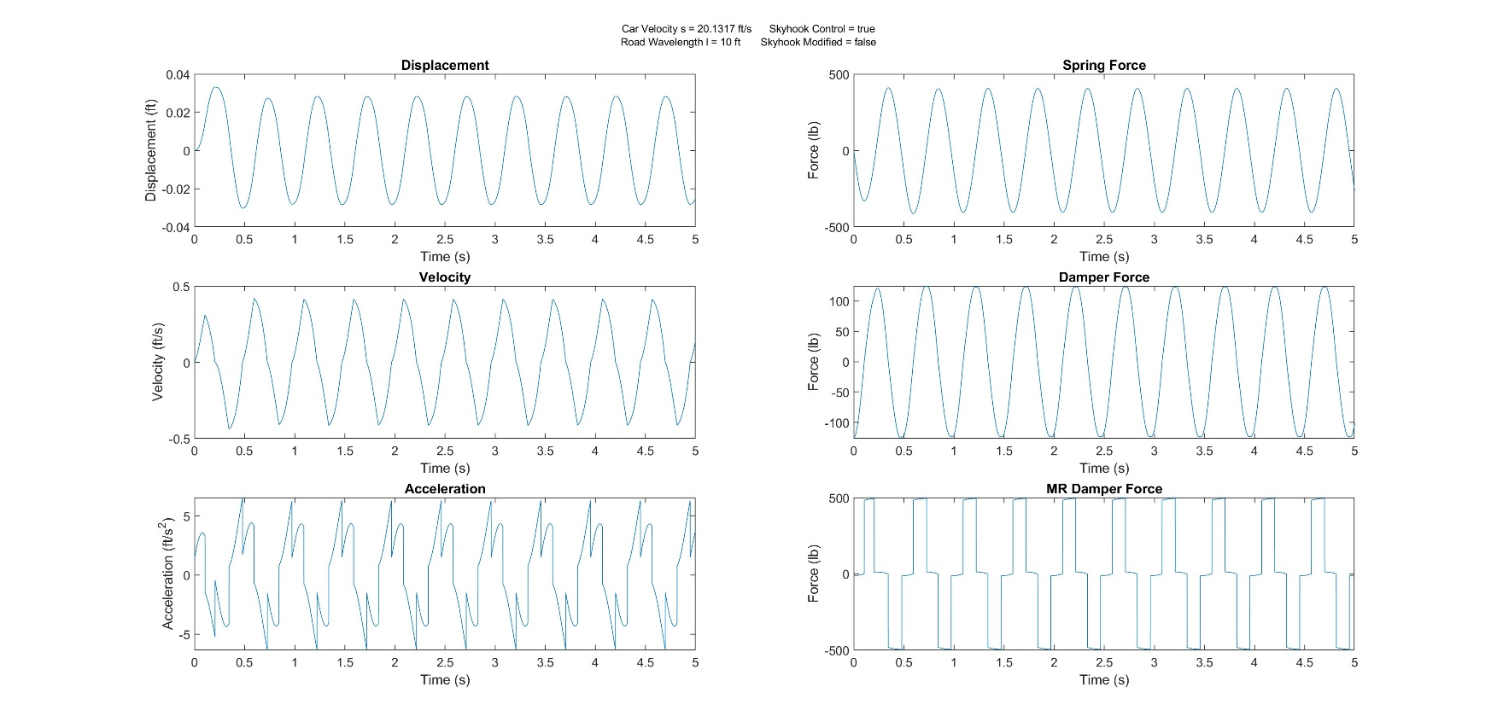

### Figure 7: MR Damping Suspension with Modified Skyhook Control When Car Speed = 20.1317 ft/sec & Road Wavelength = 10 ft

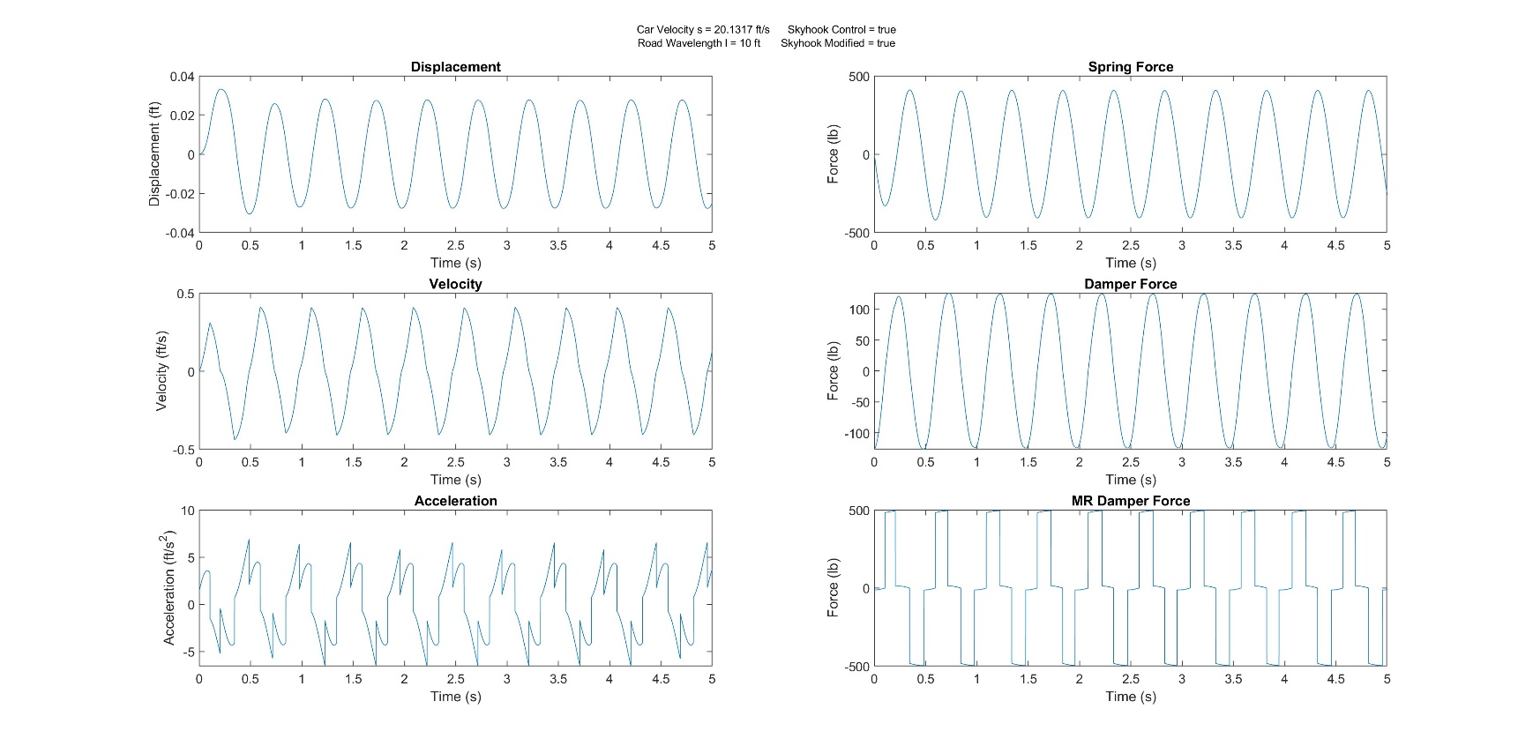

### Figure 8: No MR Damping Suspension When Car Speed = 58.66 ft/sec & Road Wavelength = 10 ft

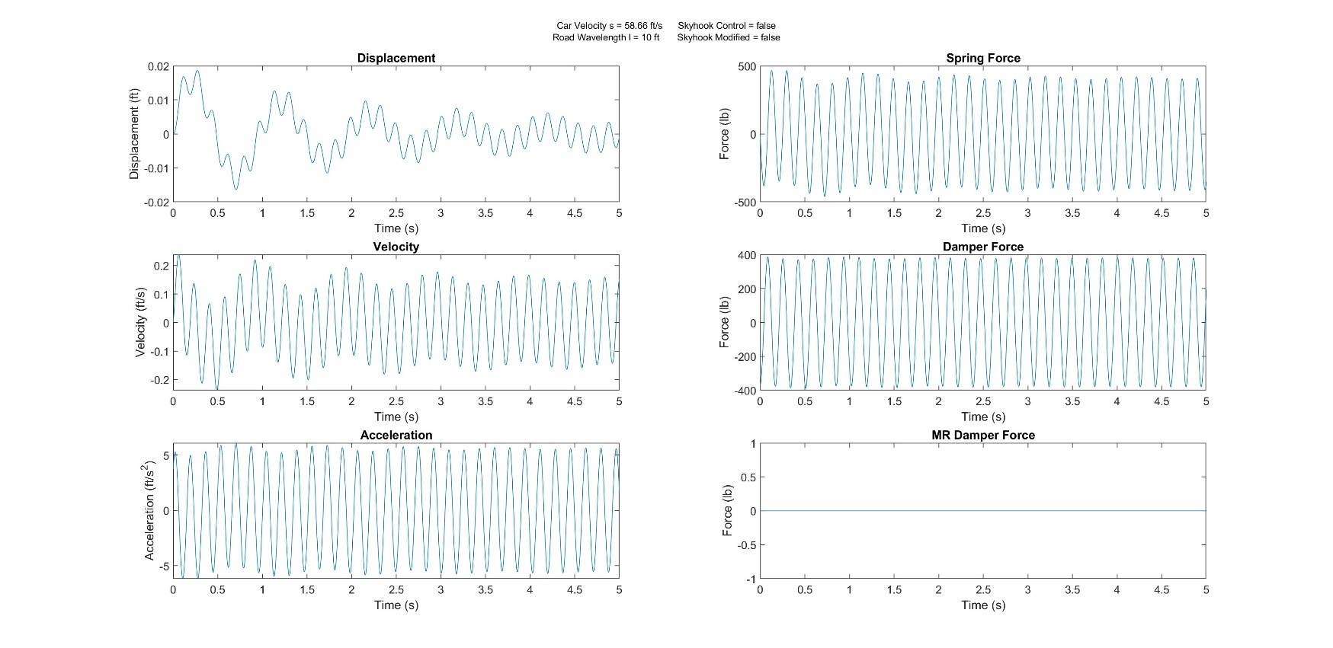

### Figure 9: MR Damping Suspension with Skyhook Control When Car Speed = 58.66 ft/sec & Road Wavelength = 10 ft

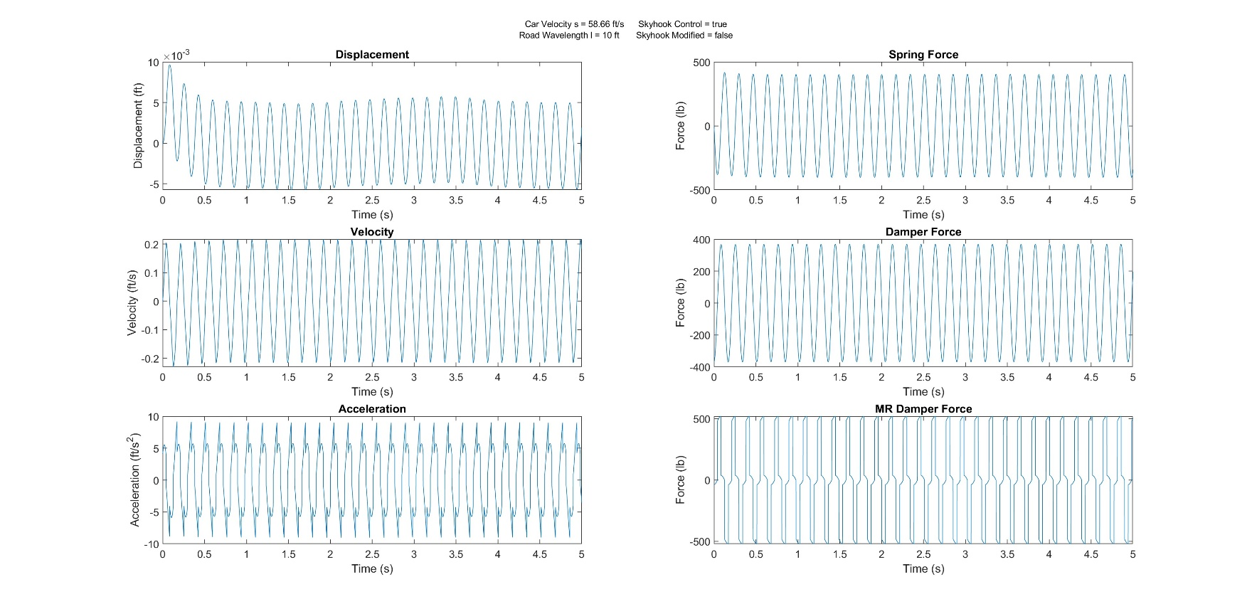

### Figure 10: MR Damping Suspension with Modified Skyhook Control When Car Speed = 58.66 ft/sec & Road Wavelength = 10 ft

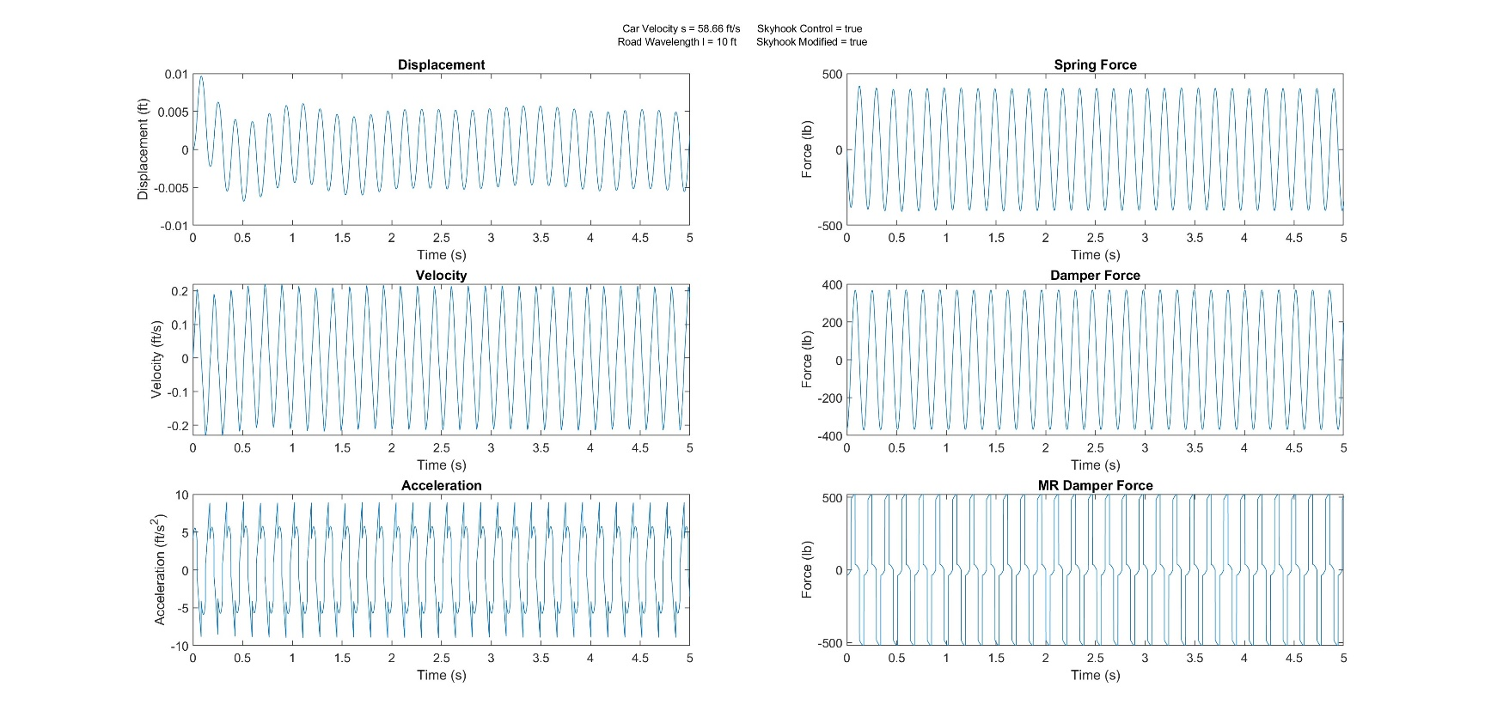

### Figure 11: No MR Damping Suspension When Car Speed = 88 ft/sec & Road Wavelength = 10 ft

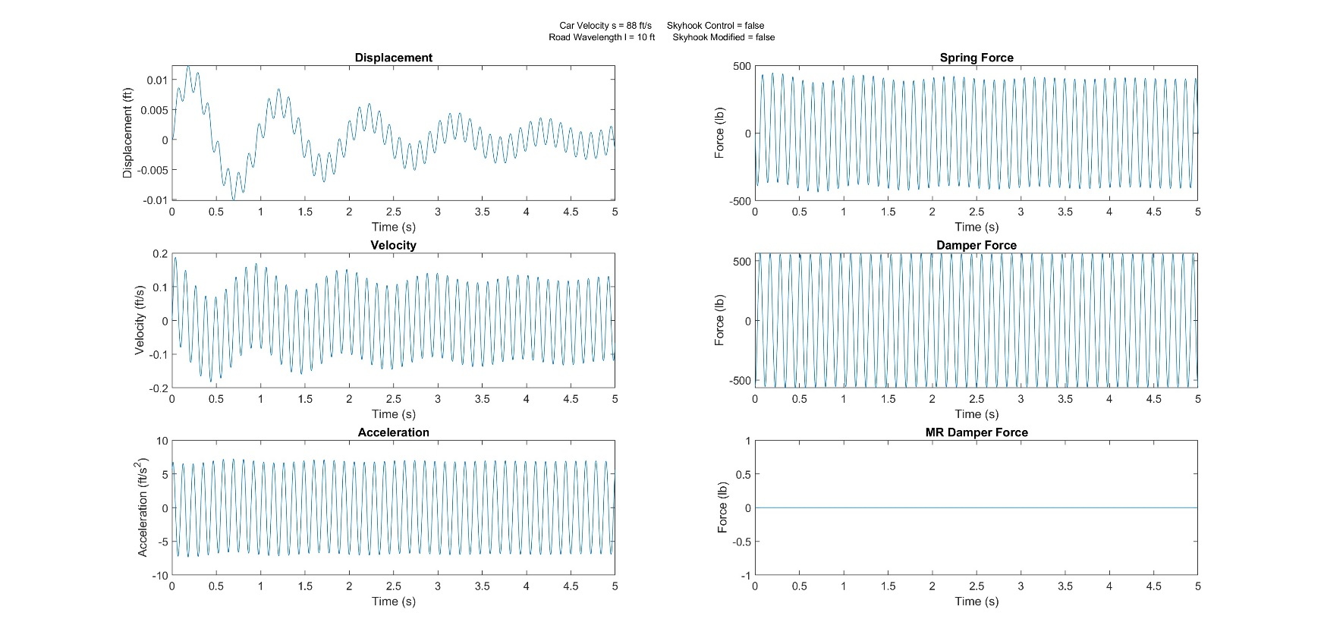

### Figure 12: MR Damping Suspension with Skyhook Control When Car Speed = 88 ft/sec & Road Wavelength = 10 ft

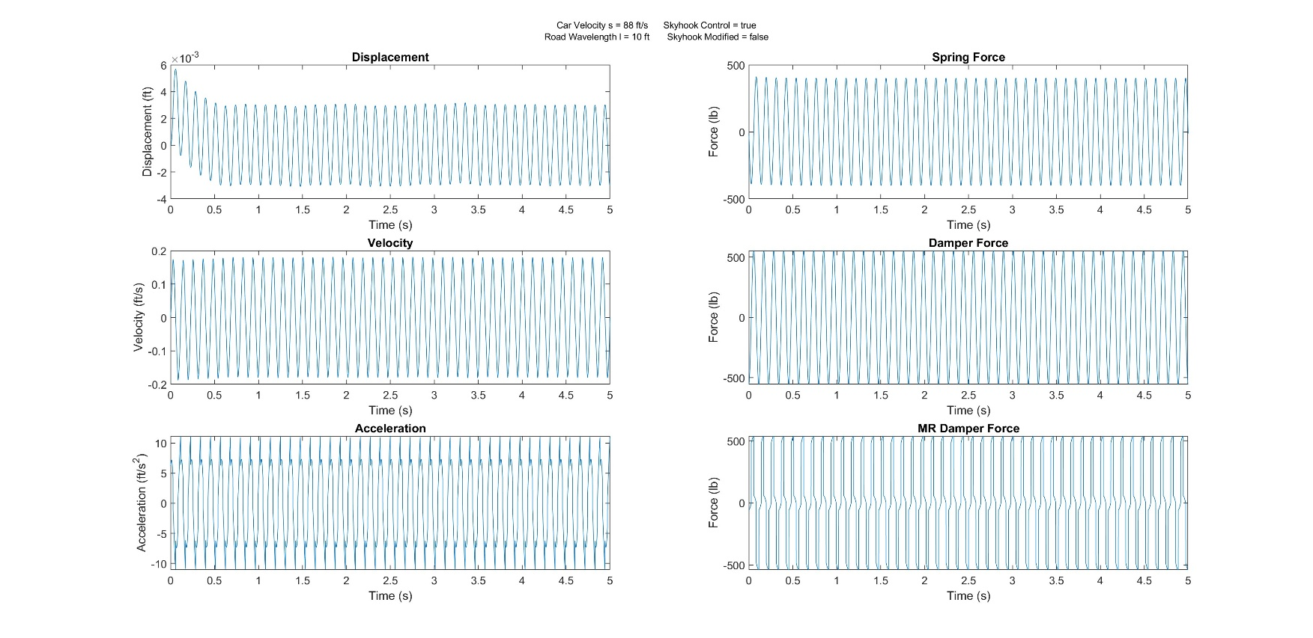

### Figure 13: MR Damping Suspension with Modified Skyhook Control When Car Speed = 88 ft/sec & Road Wavelength = 10 ft

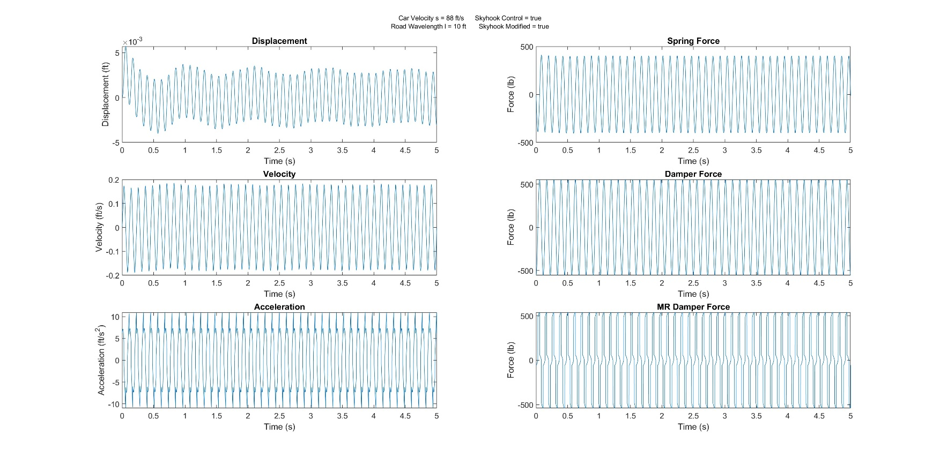

### Figure 14: No MR Damping Suspension When Car Speed = 7.333 ft/sec & Road Wavelength = 20 ft

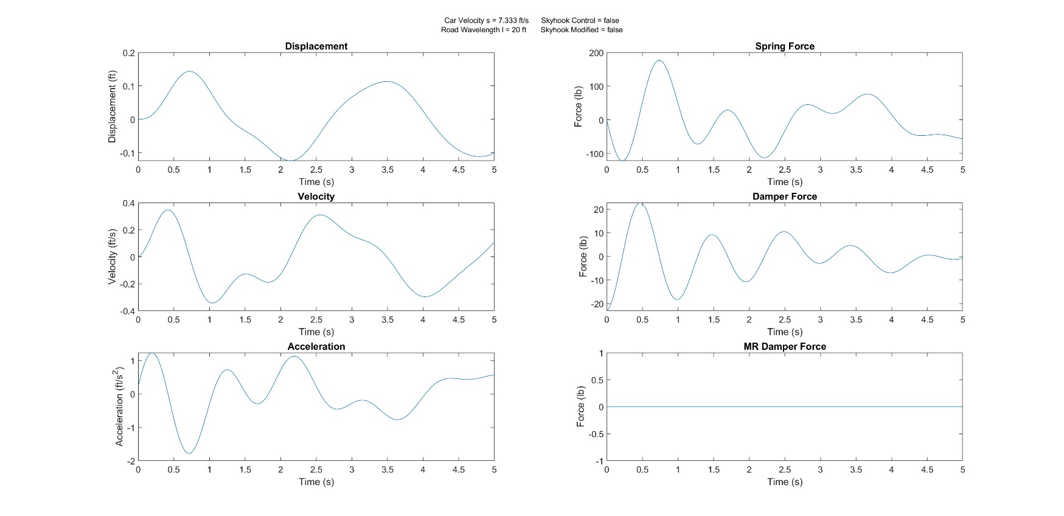

### Figure 15: MR Damping Suspension with Skyhook Control When Car Speed = 7.333 ft/sec & Road Wavelength = 20 ft

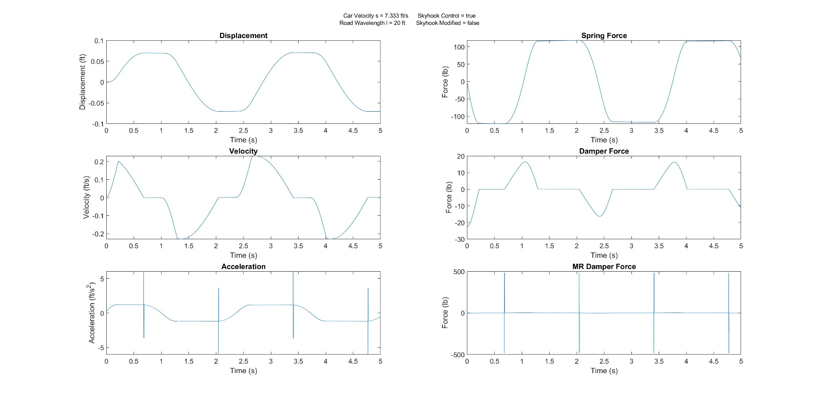

### Figure 16: MR Damping Suspension with Modified Skyhook Control When Car Speed = 7.333 ft/sec & Road Wavelength = 20 ft

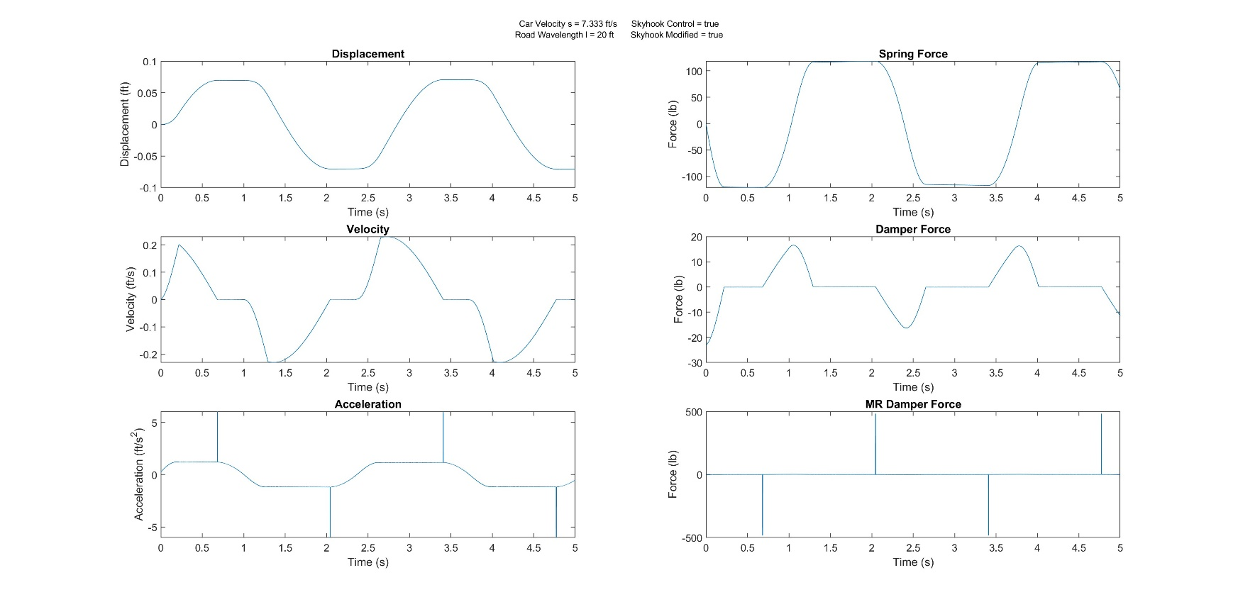

### Figure 17: No MR Damping Suspension When Car Speed = 20.1317 ft/sec & Road Wavelength = 20 ft

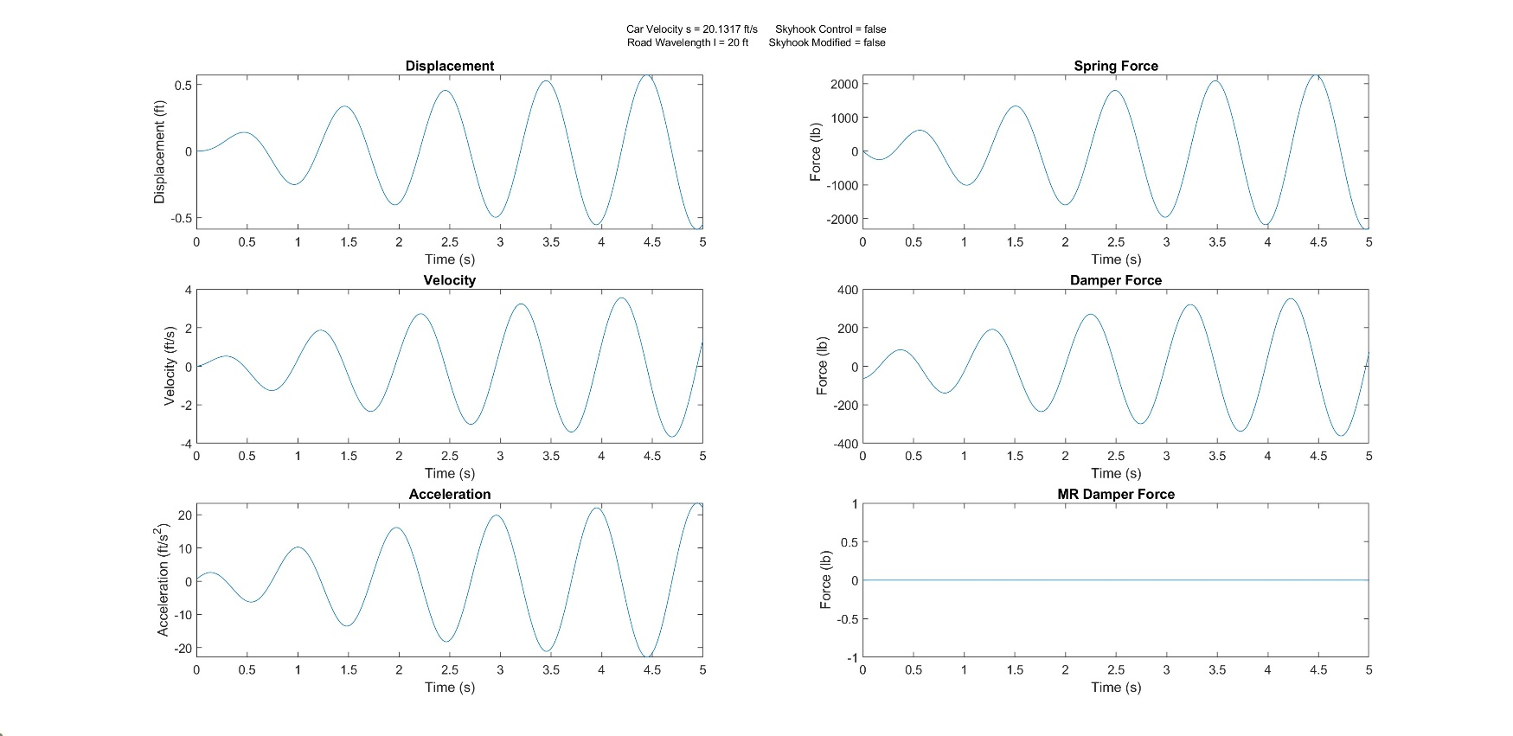

### Figure 18: MR Damping Suspension with Skyhook Control When Car Speed = 20.1317 ft/sec & Road Wavelength = 20 ft

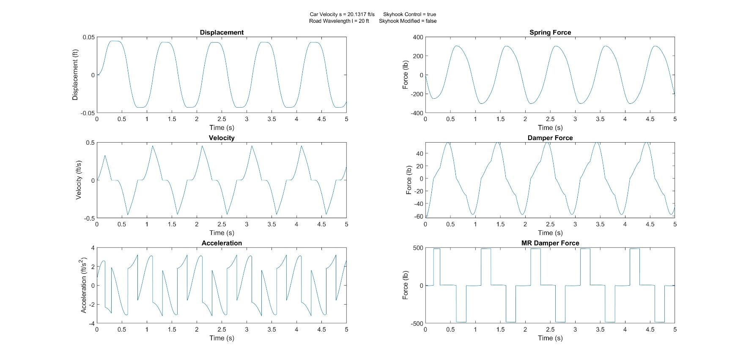

### Figure 19: MR Damping Suspension with Modified Skyhook Control When Car Speed = 20.1317 ft/sec & Road Wavelength = 20 ft

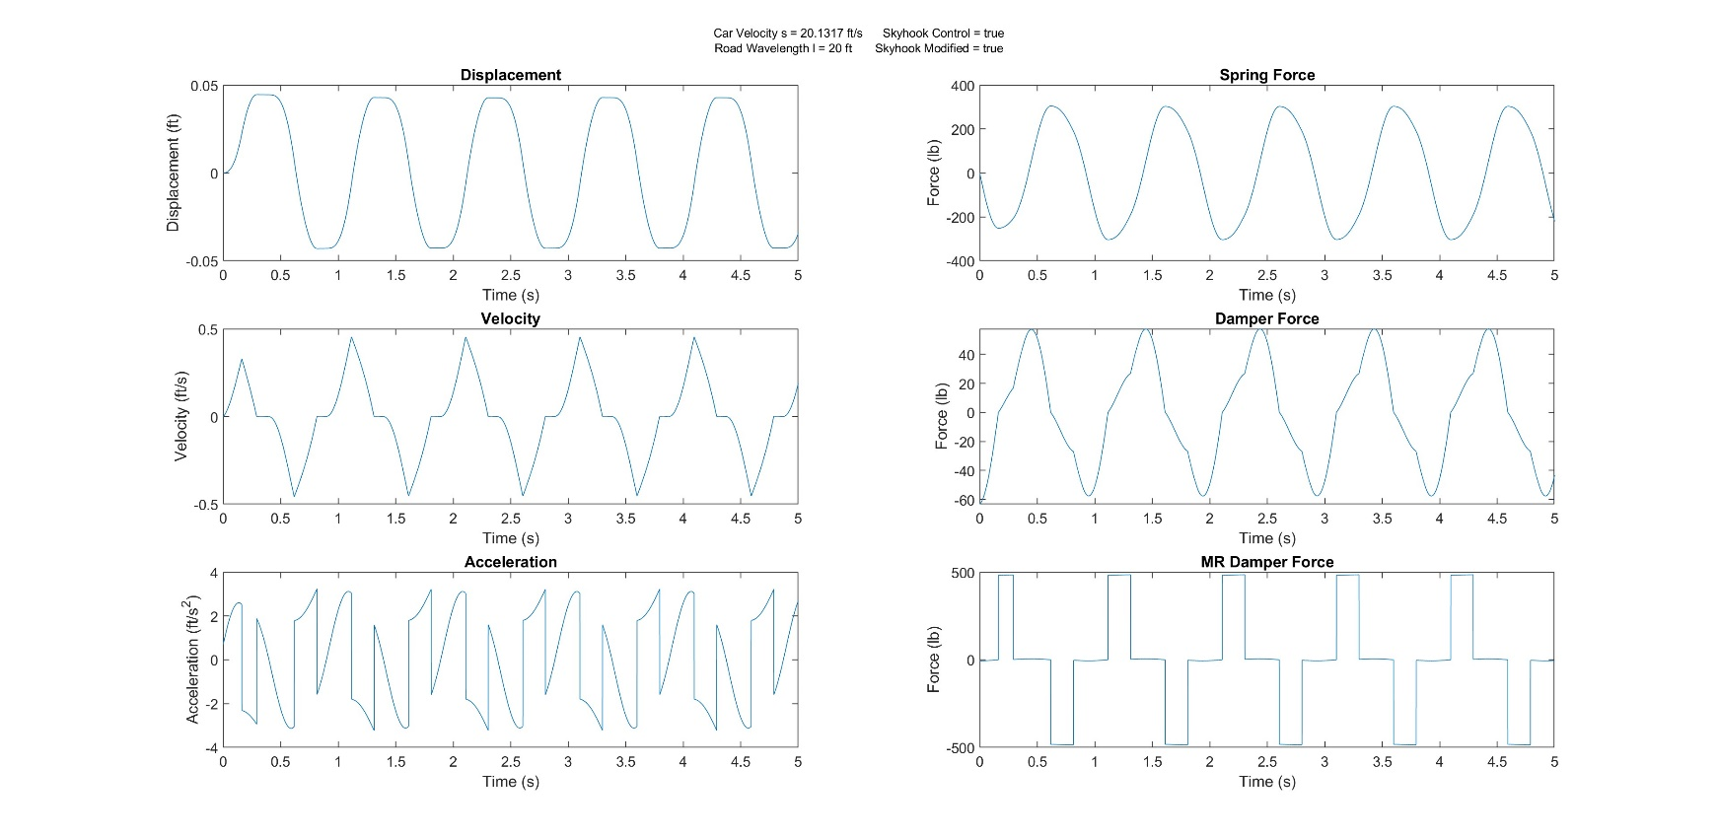

### Figure 20: No MR Damping Suspension When Car Speed = 58.66 ft/sec & Road Wavelength = 20 ft

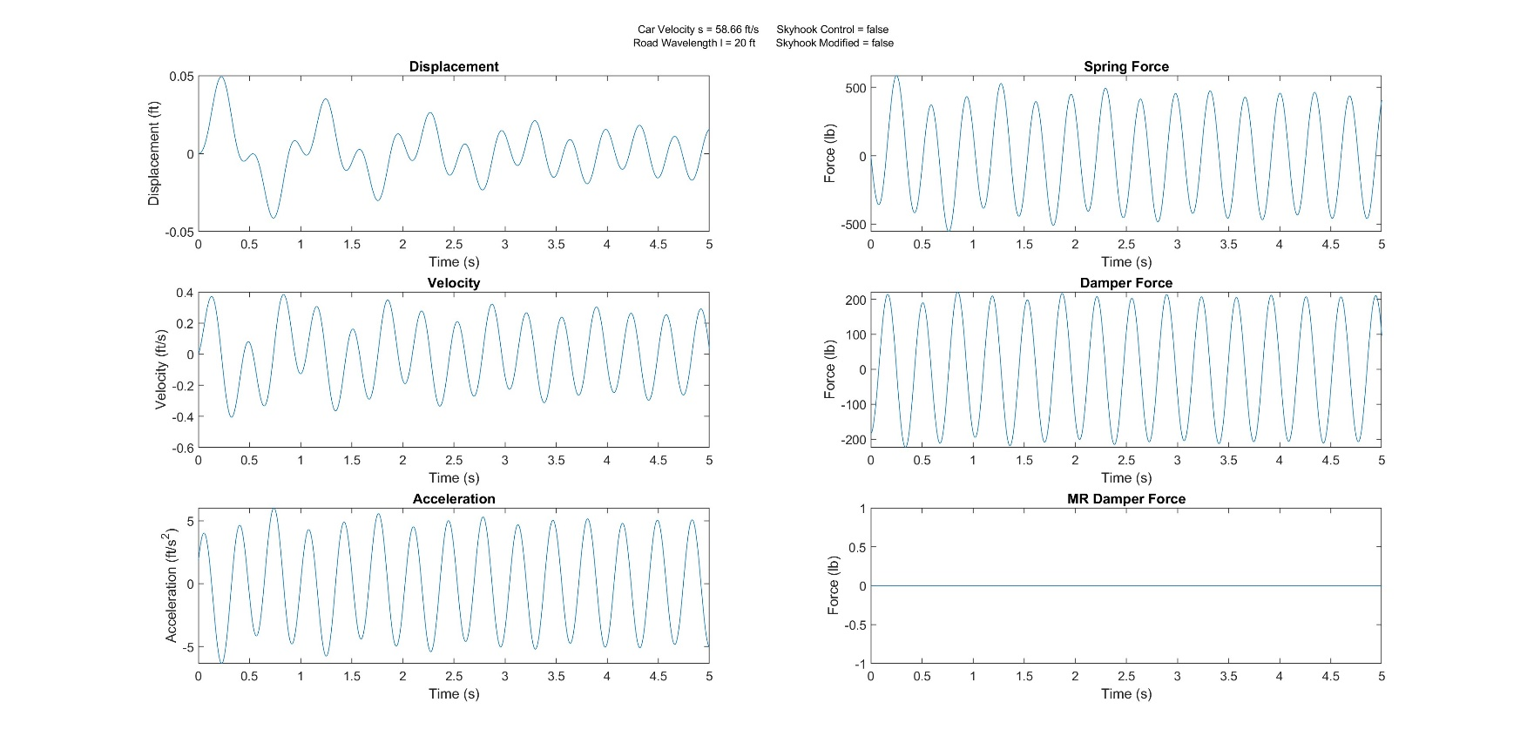

### Figure 21: MR Damping Suspension with Skyhook Control When Car Speed = 58.66 ft/sec & Road Wavelength = 20 ft

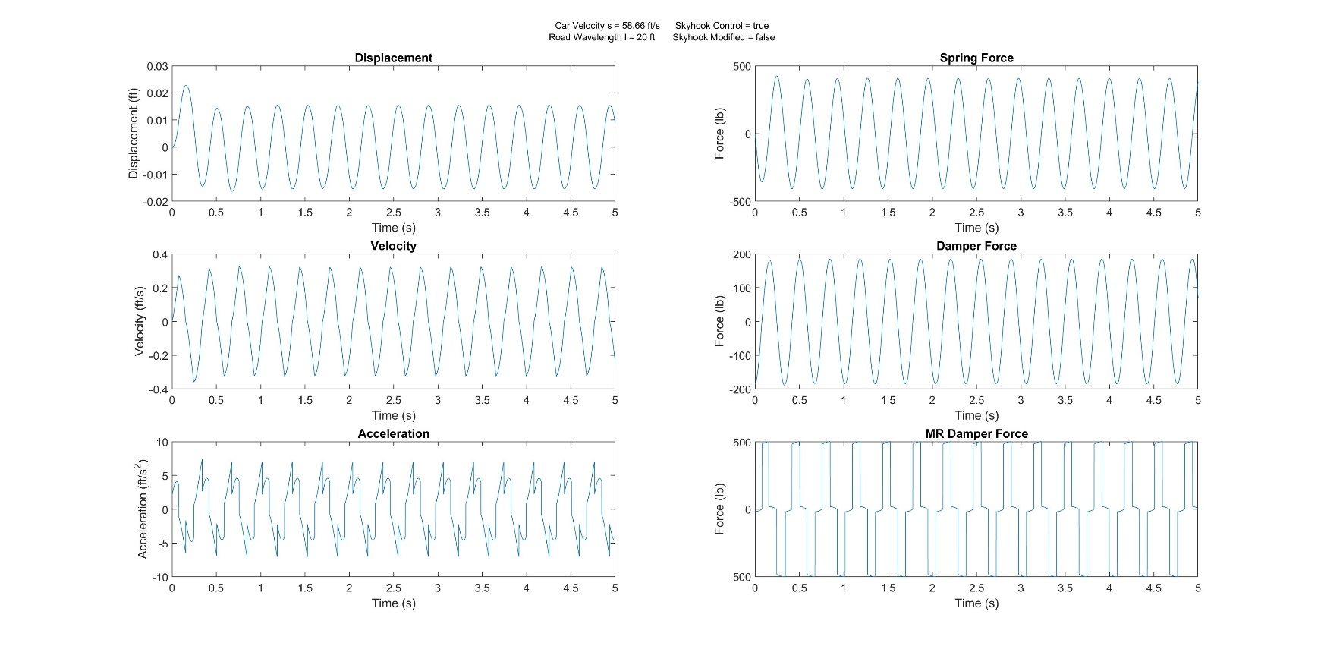

### Figure 22: MR Damping Suspension with Modified Skyhook Control When Car Speed = 58.66 ft/sec & Road Wavelength = 20 ft

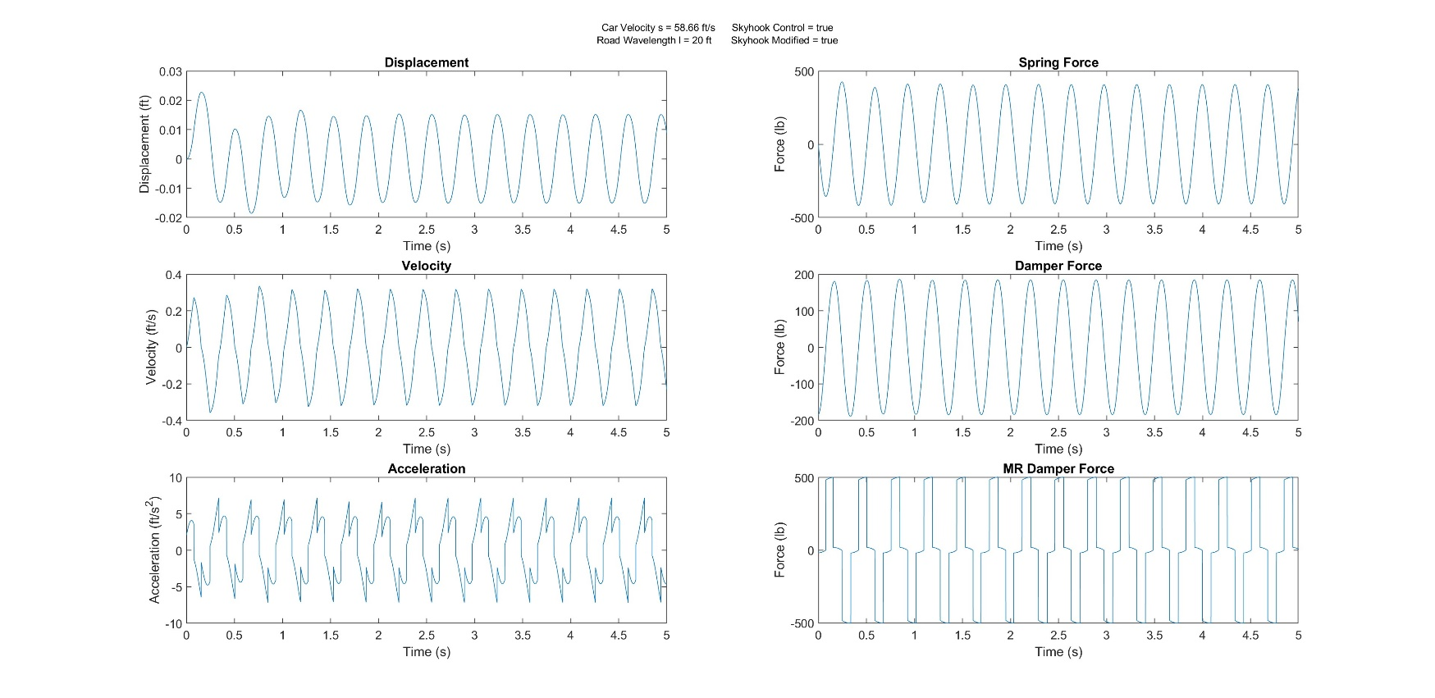

### Figure 23: No MR Damping Suspension When Car Speed = 88 ft/sec & Road Wavelength = 20 ft

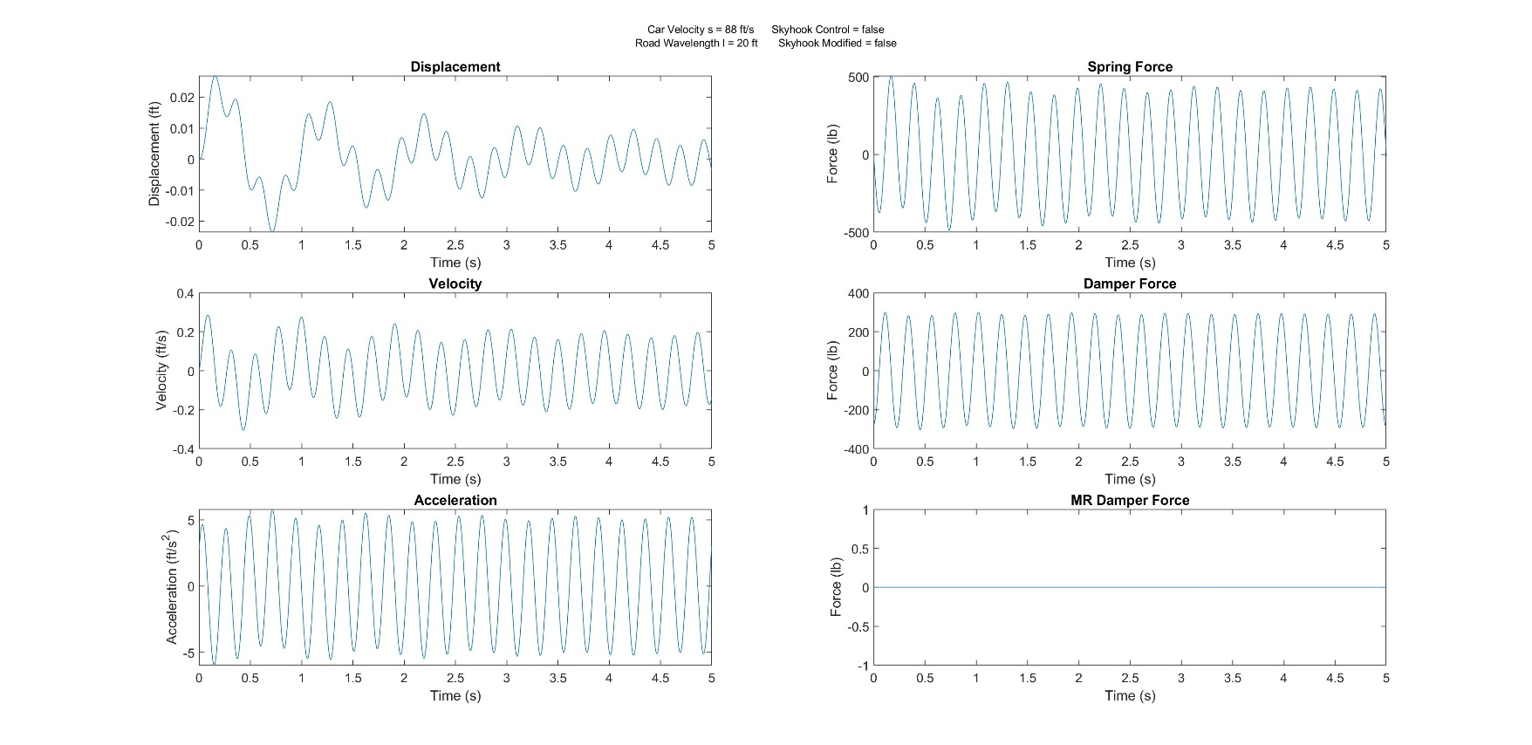

### Figure 24: MR Damping Suspension with Skyhook Control When Car Speed = 88 ft/sec & Road Wavelength = 20 ft

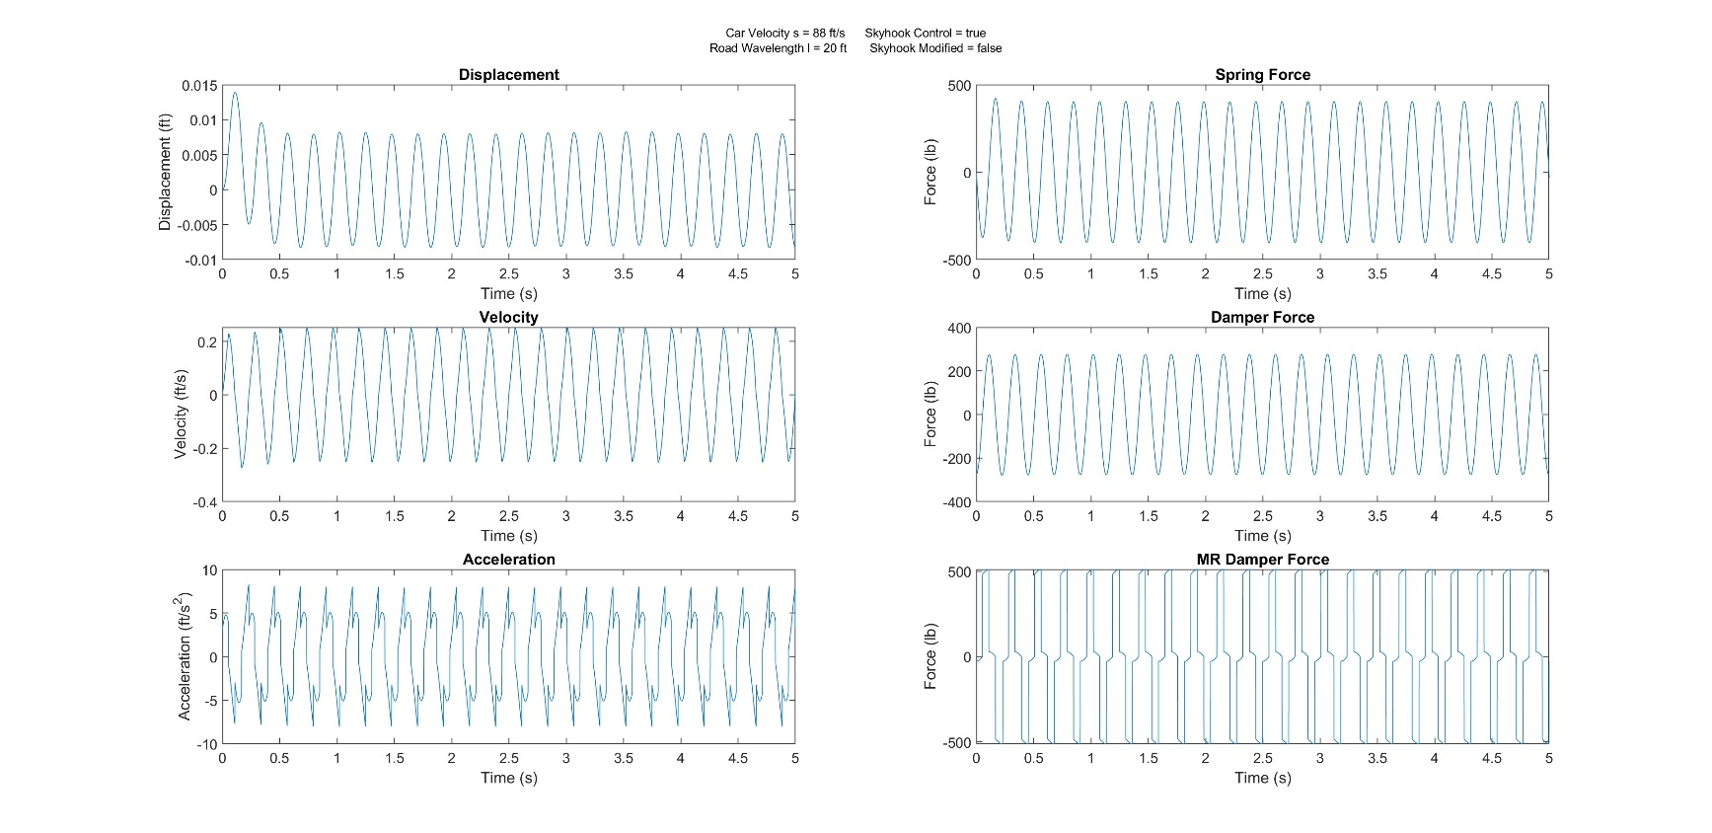

### Figure 25: MR Damping Suspension with Modified Skyhook Control When Car Speed = 88 ft/sec & Road Wavelength = 20 ft

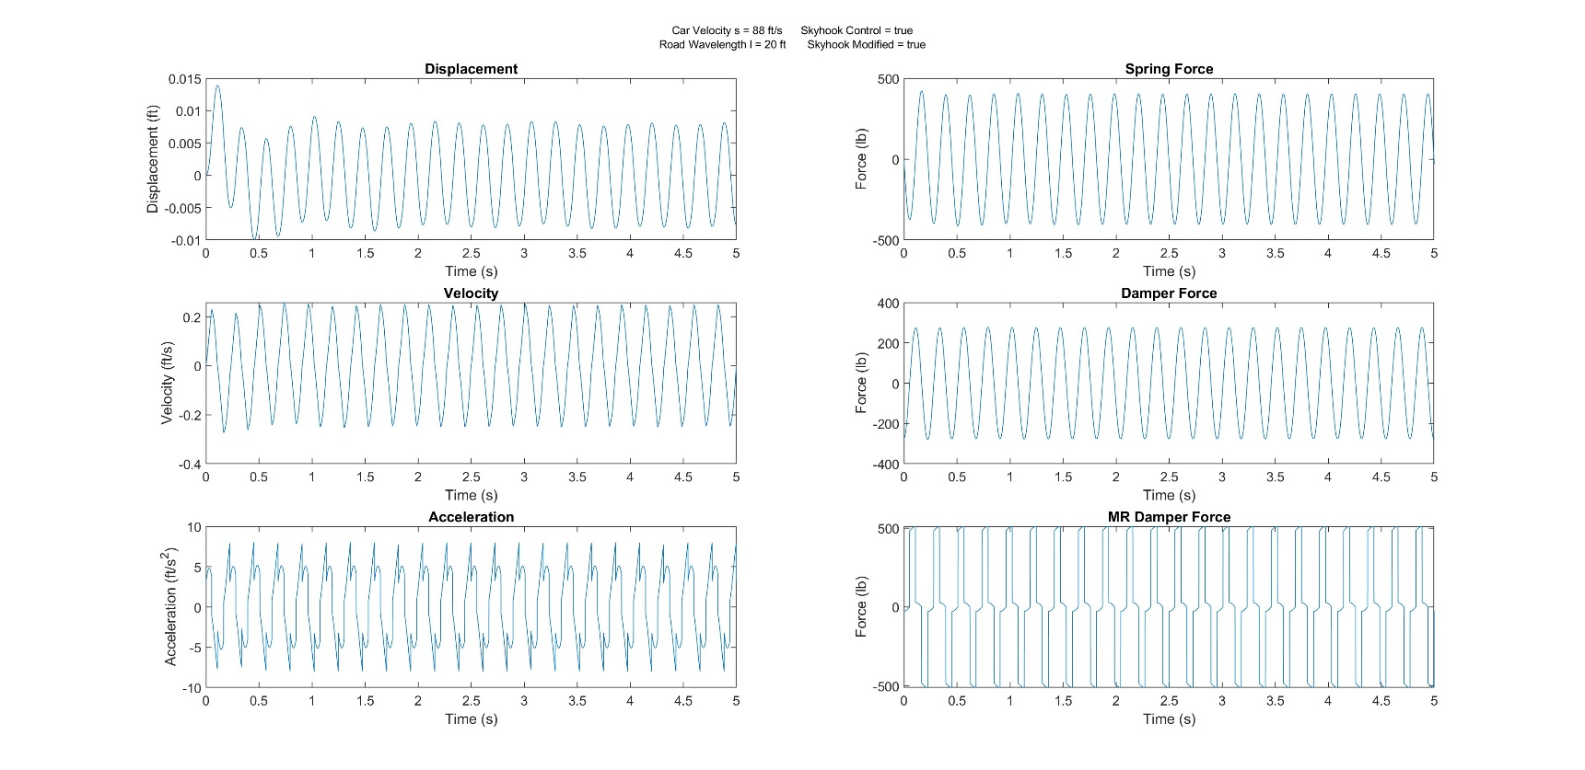

### Figure 26: No MR Damping Suspension When Car Speed = 7.333 ft/sec & Road Wavelength = 88 ft

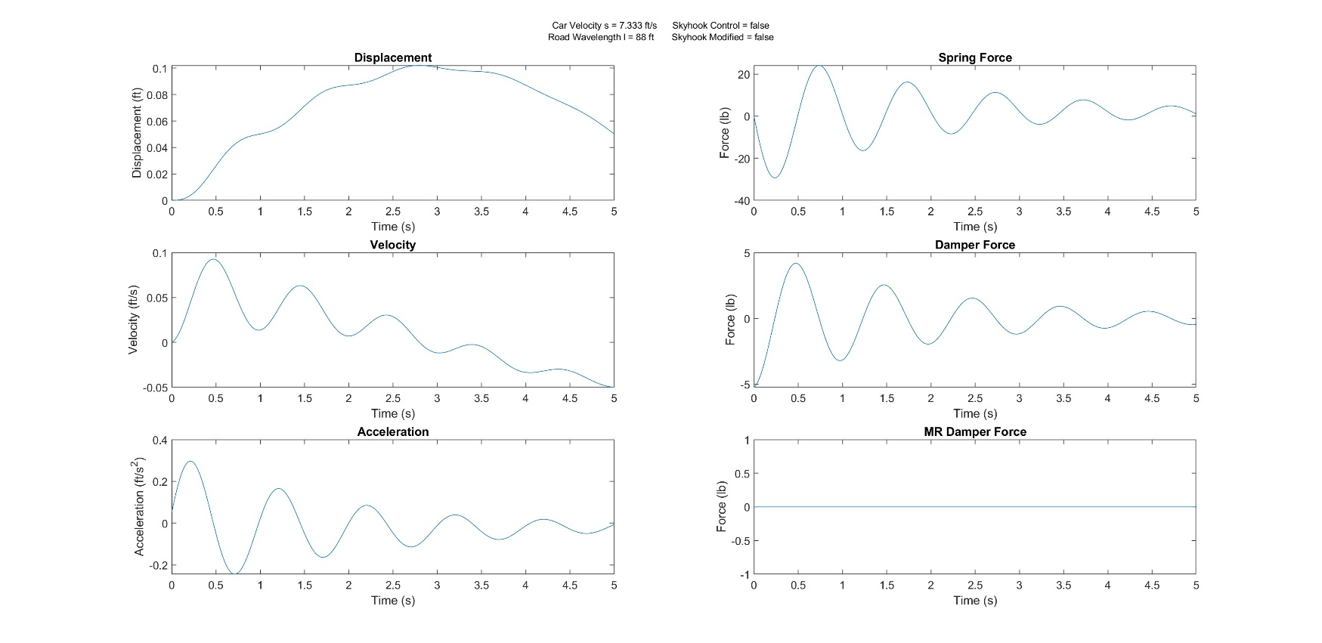

### Figure 27: MR Damping Suspension with Skyhook Control When Car Speed = 7.333 ft/sec & Road Wavelength = 88 ft

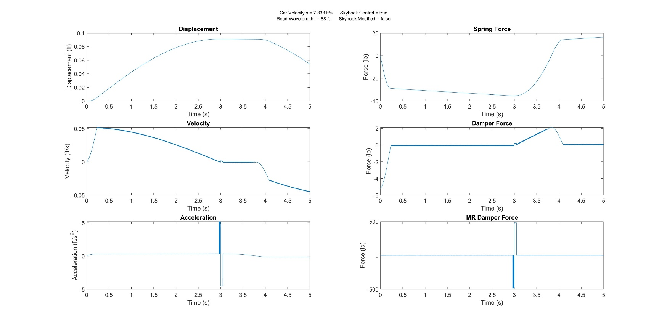

### Figure 28: MR Damping Suspension with Modified Skyhook Control When Car Speed = 7.333 ft/sec & Road Wavelength = 88 ft

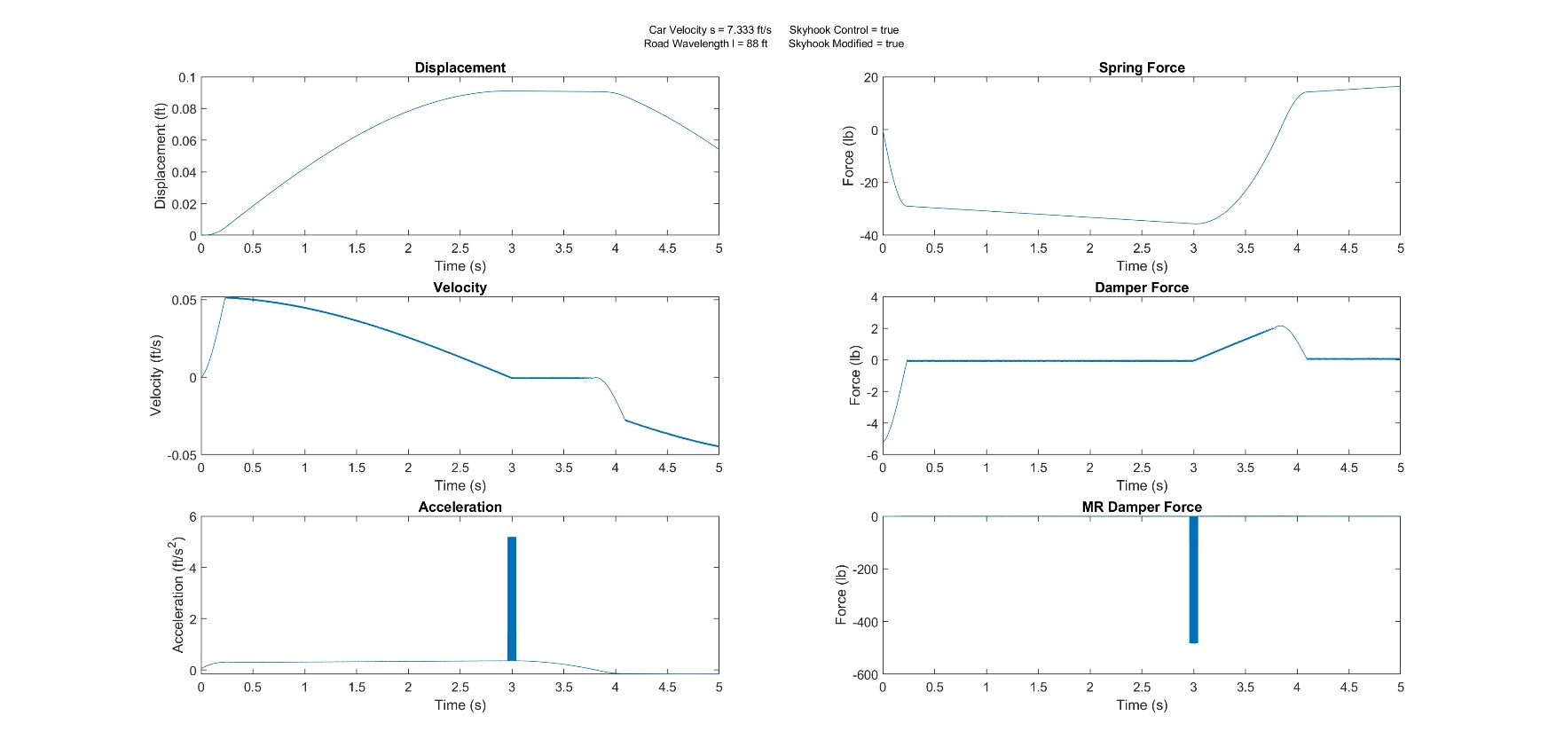

### Figure 29: No MR Damping Suspension When Car Speed = 20.1317 ft/sec & Road Wavelength = 88 ft

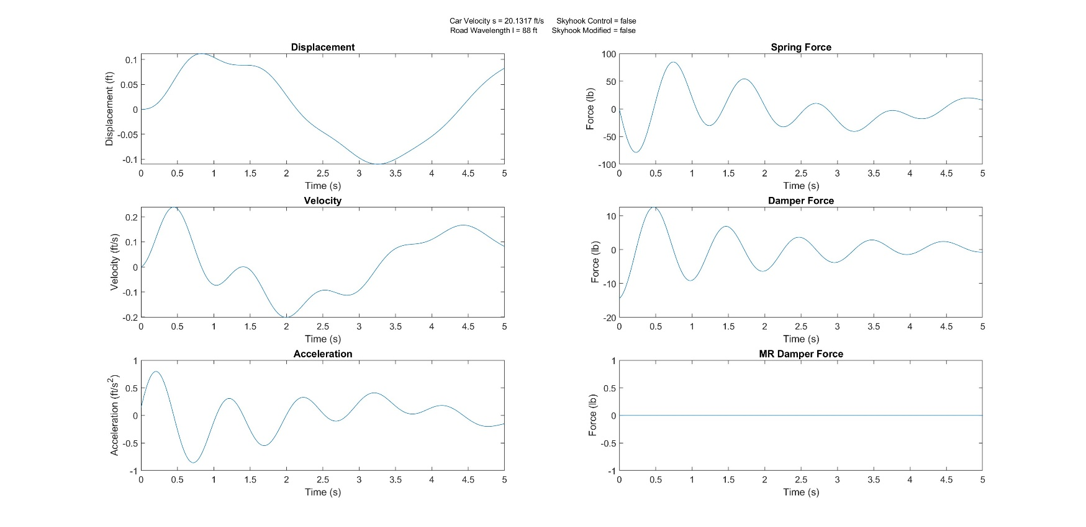

### Figure 30: MR Damping Suspension with Skyhook Control When Car Speed = 20.1317 ft/sec & Road Wavelength = 88 ft

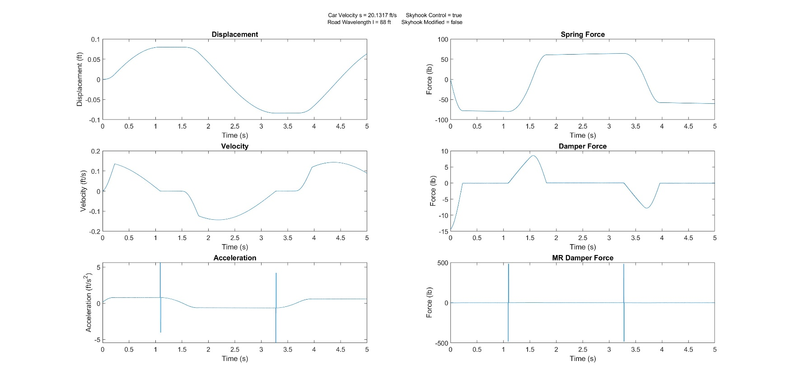

### Figure 31: MR Damping Suspension with Modified Skyhook Control When Car Speed = 20.1317 ft/sec & Road Wavelength = 88 ft

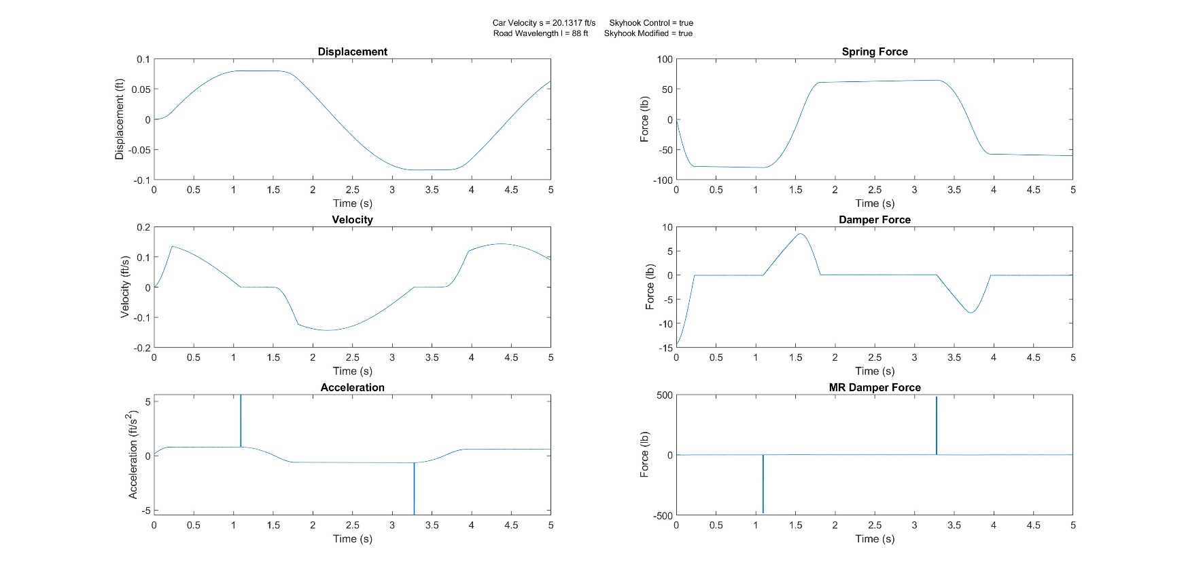

### Figure 32: No MR Damping Suspension When Car Speed = 58.66 ft/sec & Road Wavelength = 88 ft

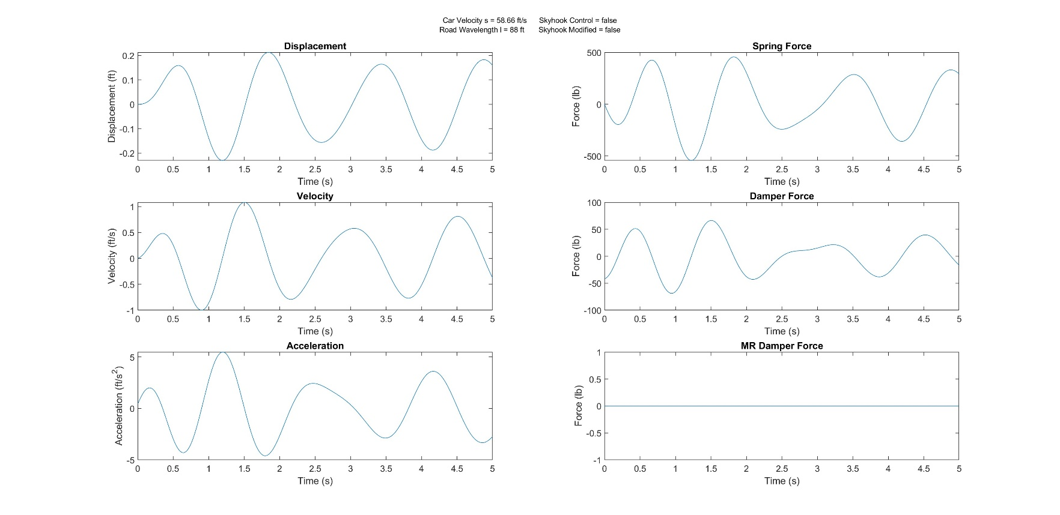

### Figure 33: MR Damping Suspension with Skyhook Control When Car Speed = 58.66 ft/sec & Road Wavelength = 88 ft

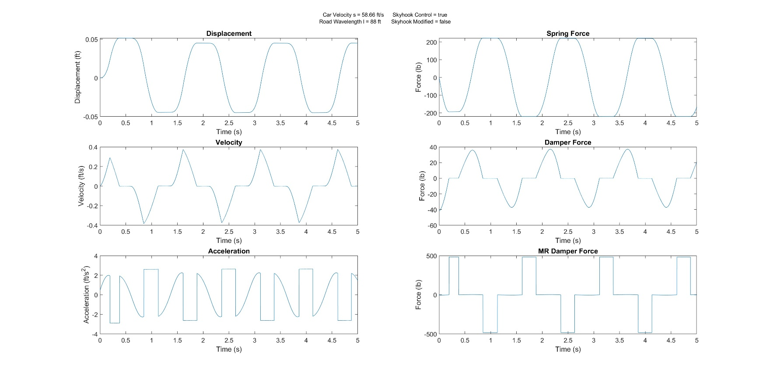

### Figure 34: MR Damping Suspension with Modified Skyhook Control When Car Speed = 58.66 ft/sec & Road Wavelength = 88 ft

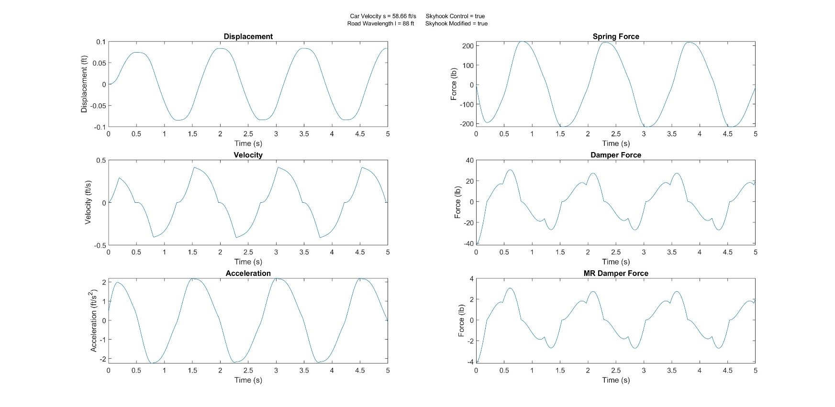

### Figure 35: No MR Damping Suspension When Car Speed = 88 ft/sec & Road Wavelength = 88 ft

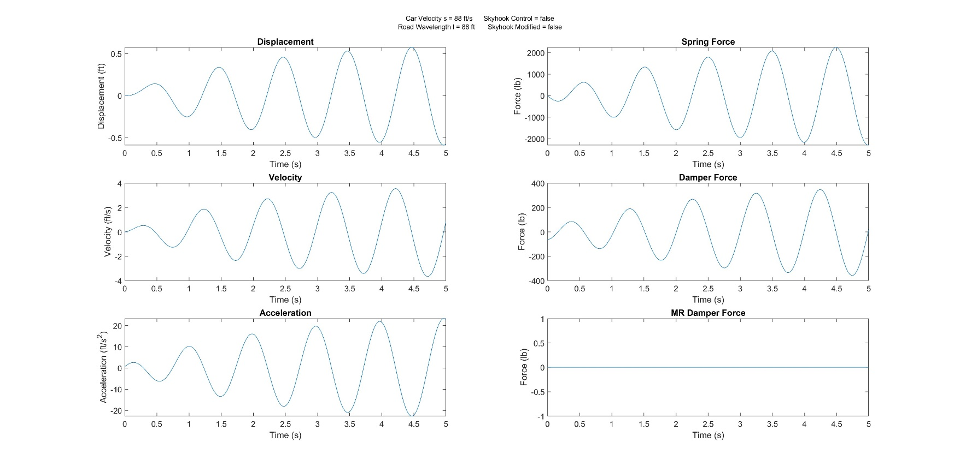

### Figure 36: MR Damping Suspension with Skyhook Control When Car Speed = 88 ft/sec & Road Wavelength = 88 ft

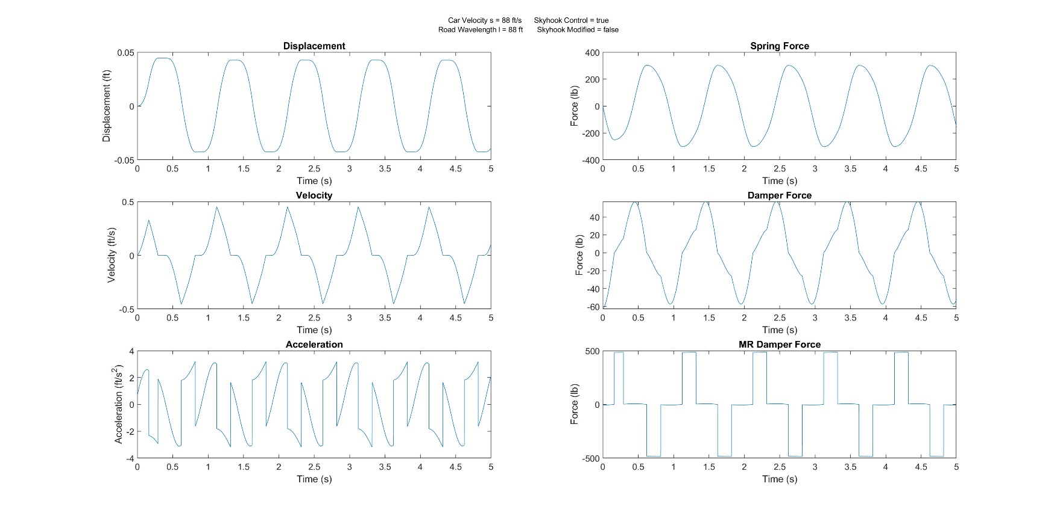

### Figure 37: MR Damping Suspension with Modified Skyhook Control When Car Speed = 88 ft/sec & Road Wavelength = 88 ft

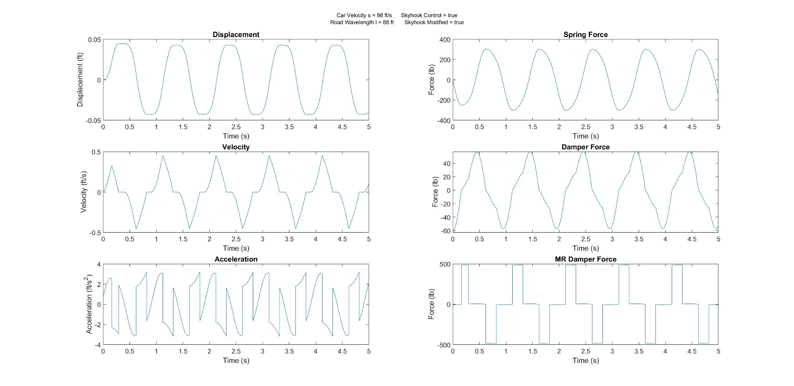

## MATLAB Code

clear all;

clc;

%Factor Variables

s = input('Car Speed, 7.333, 20.1317, 58.66, 88 ft/s: ');

l = input('Road Wavelength, 10, 20, 88 ft: ');

%Skyhook control

skyhook = logical(input(['Use Skyhook Control Algorithm?' ...

' 0 (no) or 1 (yes): ']));

if skyhook == true

skyhook_mod = logical(input(['Modify Skyhook Control Algorithm?' ...

' 0 (no) or 1 (yes): ' ]));

else

skyhook_mod = false;

end

%Constant Input Variables

K = 4000; %lb/ft (stiffness of car suspension)

W = 3220; %lb (weight of car)

g = 32.2; %ft/sec^2 (acceleration due to gravity)

C = 100; %lb*sec/ft (damping coefficient of car suspension)

Cmr = 10; %lb*sec/ft (damping coefficient of MR damper suspension)

y0 = 0.1; %ft (amplitude of road input)

Fyieldmx = 483; %lb (max force in MR damper)

%Integration Constant

B = 1/4; %Beta

L = 1/2; %Lambda

dt = 0.0005; %dsec (time step)

%Calculated Variables

M = W / g; %lb/ft/sec^2 (mass of car)

we = 2 * pi * s / l; %Hz excitation frequency

wn = (K / M) ^ (1/2); %Hz natural frequency

wratio = we / wn; %Frequency Ratio

%iInitialize integration variables to zero

x0 = 0.; %old displacement

dx0 = 0.; %old velocity

ddx0 = 0.; %old acceleration

x1 = 0.; %new displacement

dx1 = 0.; %new velocity

ddx1 = 0.; %new acceleration

%The number of integration time points

ntimepts = 10000;

%Time Loop, integration loop

for itime = 1:ntimepts

%Road position (ft) and derivative

y = y0 * sin(we * itime * dt);

dy = we * y0 * cos(we * itime * dt);

ddy = y0 * -1 * we^2 * sin(we * itime * dt);

%integration force balance loop

for iter = 1:10

%Displacement & Velocity Newmark Beta Equations

x1 = x0 + (dx0 * dt) + (((0.5 - B) * ddx0) + (B * ddx1)) * dt^2;

dx1 = dx0 + (((1 - L) * ddx0) + (L * ddx1)) * dt;

%Compute Fyield with MR Damper

if skyhook == true

%Modified Skyhook Algorithm

if skyhook_mod == true

if dx1 > 0

if dx1 > dy

if ddx1 > ddy

Fyield = Fyieldmx;

else

Fyield = 0;

end

else

Fyield = 0;

end

else

if dx1 > dy

Fyield = 0;

else

if ddx1 > ddy

Fyield = 0;

else

Fyield = Fyieldmx;

end

end

end

%Original Skyhook Algorithm

else

if dx1 > 0 && dx1 > dy

Fyield = Fyieldmx;

elseif dx1 > 0 && dx1 <= dy

Fyield = 0;

elseif dx1 < 0 && dx1 > dy

Fyield = 0;

else

Fyield = Fyieldmx;

end

end

%Calculate acceleration

Fs = K * (x1 - y); %Spring Force

Fd = C * (dx1 - dy); %Damper Force

Fa = (Fyield * sign(dx1 - dy)) + (Cmr * (dx1 - dy)); %MR Force

ddx1 = (-1 / M) * (Fs + Fd + Fa); %Acceleration

else

%standard suspension

Fs = K * (x1 - y);

Fd = C * (dx1 - dy);

ddx1 = (-1 / M) * (Fs + Fd);

end

end

%Set old values equal to new values

x0 = x1;

dx0 = dx1;

ddx0 = ddx1;

%store variables in arrays

x(itime) = x1; %ft

v(itime) = dx1; %ft/s

a(itime) = ddx1; %ft/sec^2

time(itime) = itime * dt; %sec

spring_force(itime) = Fs; %lb

damper_force(itime) = Fd; %lb

if skyhook == true

mr_force(itime) = Fa; %lb

else

mr_force(itime) = 0;

end

end

%Calculate max values in second half of array

xmax = max(x(0.5 * length(x):length(x)), [], 'ComparisonMethod', 'abs');

vmax = max(v(0.5 * length(v):length(v)), [], 'ComparisonMethod', 'abs');

amax = max(a(0.5 * length(a):length(a)), [], 'ComparisonMethod', 'abs');

spring_max = max(spring_force(0.5 * ...

length(spring_force):length(spring_force)), ...

[], 'ComparisonMethod', 'abs');

damper_max = max(damper_force(0.5 * ...

length(damper_force):length(damper_force)), ...

[], 'ComparisonMethod', 'abs');

mr_max = max(mr_force(0.5 * ...

length(mr_force):length(mr_force)), ...

[], 'ComparisonMethod', 'abs');

%Print Variables

fprintf('Car Weight (W) = %i lb\n', W)

fprintf('Acceleration Due to Gravity (g) = %i ft/s^2\n', g)

fprintf('Car Mass (M) = %i lb*sec/ft\n', M)

fprintf('Suspension Stiffness (K) = %i lb/ft\n', K)

fprintf('Car Suspension Damping Coefficient (C) = %i lb*sec/ft\n', C)

fprintf('MR Suspension Damping Coefficient (Cmr) = %i lb*sec/ft\n', Cmr)

fprintf('Max Force in MR Damper (Fyieldmx) = %i lb\n', Fyieldmx)

fprintf('Road Amplitude (y0) = %i ft\n', y0)

fprintf('Integration Constant Beta (B) = %i\n', B)

fprintf('Integration Constant Lambda (L) = %i\n', L)

fprintf('Time Step (dt) = %i sec\n', dt)

fprintf('Number of Time Steps (ntimepts) = %i\n', ntimepts)

fprintf('Road Wavelength (l) = %i ft\n', l)

fprintf('Car Speed (s) = %i ft/sec\n', s)

fprintf('Excitation Frequency (we) = %i Hz\n', we)

fprintf('Natural Frequency (wn) = %i Hz\n', wn)

fprintf('Frequency Ratio (wratio) = %i\n', wratio)

fprintf('Car Max Displacement (xmax) = %i ft\n', xmax)

fprintf('Car Max Velocity (vmax) = %i ft/sec\n', vmax)

fprintf('Car Max Acceleration (amax) = %i ft/sec^2\n', amax)

fprintf('Max Spring Force (spring_max) = %i lb\n', spring_max)

fprintf('Max Damper Force (damper_max) = %i lb\n', damper_max)

fprintf('Max MR Damper Force (mr_max) = %i lb\n', mr_max)

figure(1)

sgtitle({ ...

['Car Velocity s = ' num2str(s) ' ft/s', ' Skyhook Control = ' mat2str(skyhook)]

['Road Wavelength l = ' num2str(l) ' ft', ' Skyhook Modified = ' mat2str(skyhook_mod)]}, 'FontSize', 8);

subplot(3,2,1)

plot(time,x)

title('Displacement')

xlabel('Time (s)')

ylabel('Displacement (ft)')

subplot(3,2,3)

plot(time, v)

title('Velocity')

xlabel('Time (s)')

ylabel('Velocity (ft/s)')

subplot(3,2,5)

plot(time, a)

title('Acceleration')

xlabel('Time (s)')

ylabel('Acceleration (ft/s^2)')

subplot(3,2,2)

plot(time, spring_force)

title('Spring Force')

xlabel('Time (s)')

ylabel('Force (lb)')

subplot(3,2,4)

plot(time, damper_force)

title('Damper Force')

xlabel('Time (s)')

ylabel('Force (lb)')

subplot(3,2,6)

plot(time, mr_force)

title('MR Damper Force')

xlabel('Time (s)')

ylabel('Force (lb)')